Decision 4 – Rejected Transaction Defaults: Stata comparison
Verification of the COOPECON app (branch migration, HEAD d202e00) against the professor's Decision 4 design document "Decision 4 - Rejected Transaction Defaults 040926-2.docx" and the Stata file Stata_File_Decision4_050926.dta (280 participants). Prepared 2026-10-06 by the migration controller.

How to read this document
Each step shows, side by side, the Stata figure (or Stata output) and the corresponding app screen or value, states the exact settings that produce the pair, and ends with a verdict line. The Stata figures are the ones embedded in the professor's document (with all tracked changes accepted; the previous revision's figures that the tracked changes deleted are not used). Stata itself could not be run (the StataNow licence on this machine expired on 30 Aug 2026), so every Stata summary number quoted here (Obs / Mean / SD / Min / Max, counts) was computed from the columns stored in the .dta with pandas, exactly as "summarize" / "tab" would report them. App charts are exported from the exact Plotly figure objects of the running app (Chrome, Plotly.toImage); app screens are Chrome captures; app numbers come from the same seam/engine path the "Run" buttons execute.

Settings used for every comparison (Stata parameter values)
Setting | Value | Why
Page 1 › Population Mode | Research Baseline | the original 280 participants, no stochastic component (Stata: the 280 observations)
Page 1 › Number of Agents | 280 | N ≤ 280 → the first 280 original rows in order, no random draw; seed irrelevant (42 used)
Page 1 › Income | professor's income file (research modes) | z_net_income = std(income) over the 280, as in the .dta
Page 2 › Decision 4 › Income Specification | Continuous only / Categorical only | WTP and Risk-Taking are the only income-using elements
Page 2 › Decision 4 › Intercepts β0…β4 | all 0.0000 | the .dta embeds no intercept. App default β0 (Options List Length) = 0.05 must be set to 0 for the Stata comparison (app default kept)
Page 2 › Decision 4 › Flexibility Anchor Mix W_OFlex | 0.25 (default) | anchored_flexibility = 0.25·z_stdactions + 0.75·z_Flexibility_calculated_ivw
Page 2 › Decision 4 › Stochastic | off (Research Baseline is always deterministic) | σ tables compared separately (step 10); a Research Specification run with σ on is shown in step 12
Histogram bins | Stata default rule min(√N, 10·log10 N) → 17 bins at N = 280 | the app applies the same rule (capped at 17); Stata plots density, the app plots the proportion of agents – identical shapes, y-axis scaled by the bin width

Summary of verdicts
Step | Stata item | App item | Verdict
1 | Standardisation (egen std of the Big-5, education, stdactions) | YAML z_scoring vs .dta summarize | Match (7 significant digits)
2 | Element equations and coefficients (TTP, Loyalty, WTP, Risk-Taking, Flexibility) | doc equations vs app sub-tabs | Match
3 | F1 histogram weighted_ttp, F2 choice_length_deterministic | app "Tendency to Plan score" / "Number of pre-selected options" | Match – 280/280 agents (β0 = 0)
4 | F3 histogram weighted_loyalty, F4 weighted_loyalty15 | app "Loyalty score" / loyalty-based options ranking | Match – 280/280 (score, segment, 5-option list)
5 | F6 histogram z_WTP_calculated, F8 WTP_calculated15 (continuous) | app WTP score / ranking, Continuous only | Match – 280/280
6 | T1 regress WTP (categorical), F5/F7 categorical WTP histograms | app quintile-effects table / WTP score, Categorical only | Coefficients match; the .dta's stored weighted_WTP_categorical was generated with a superseded formula (see step 6) – the app reproduces the document's printed code; 1 agent's segment differs from the .dta
7 | F9 histogram z_RT_calculated_hs, F12 RT_calculated15 | app Risk-Taking score / ranking, Continuous only | Match – 280/280
8 | T2 regress RT (categorical), F10/F11 categorical RT histograms | app quintile-effects table / RT score, Categorical only | Match – 280/280 (z-score and floor-rule segments)
9 | F13 z_Flexibility_calculated_ivw, F14 z_stdactions, F15 z_anchored_flexibility, F16 Flexibility_combined15 | app Flexibility score / ranking + export columns | Match – 280/280
10 | σ tables (TTP, Loyalty, WTP, Risk-Taking, Flexibility) | app "Base σ and effective σ per budget level" | Match the document literally (two arithmetic slips inside the document itself are noted)
11 | Section 6 integrated default list (Kemeny-Young + tie-break) | app "Integrated Default List" + tie statistics | App-only (no Stata counterpart); output rules hold 280/280
12 | Stochastic component (no Stata figure) | Research Specification run with σ on | App-only example; UI = engine (identical allocation)
13 | Compare both / Compare all layouts | app comparison screens | Consistent with the single-mode runs; Copula differs by construction

Step 1: Settings in the app
Page 1 (population mode and agents) and the Decision 4 tab (income specification, stochastic component, intercept override):
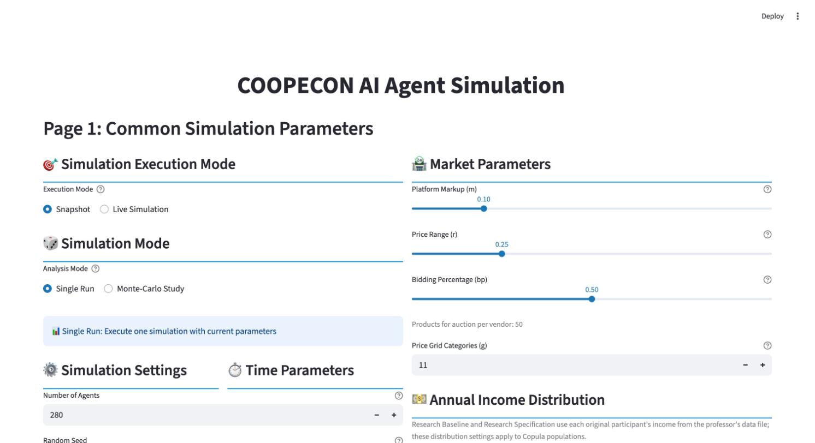
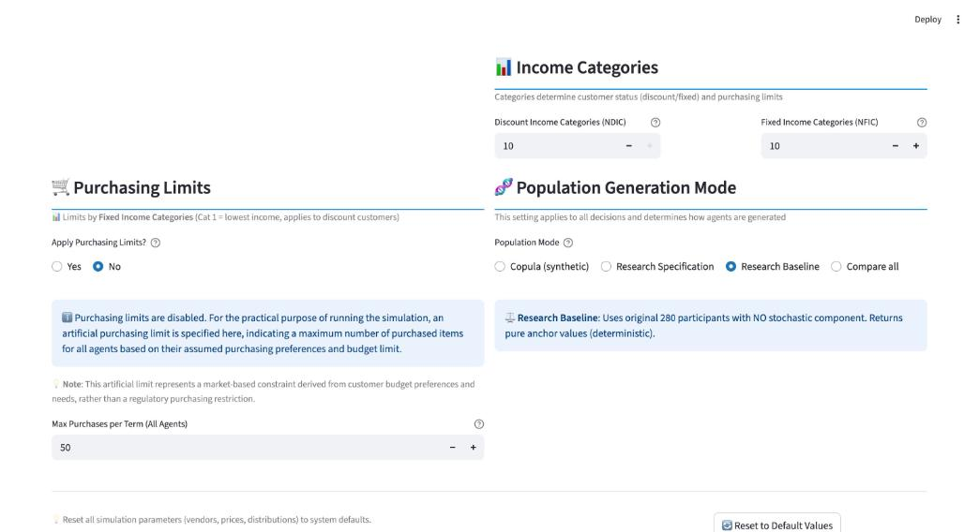
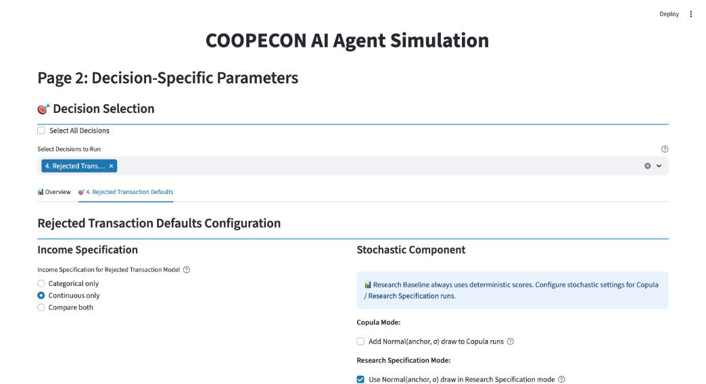
Options List Length sub-tab with the intercept override set to 0 (Research Default shows the app default 0.05):
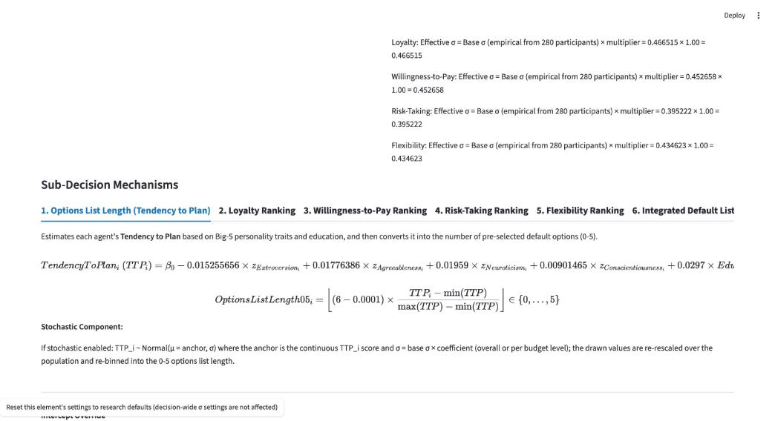

Step 2: The standardisation of values
Stata commands (document, section 5 and the per-element "Variable Standardisation" blocks):
egen z_extraversionbig5 = std(extraversionbig5)
egen z_agreeable = std(agreeable)
egen z_neuroticismbig5 = std(neuroticismbig5)
egen z_conscientiousnessbig5 = std(conscientiousnessbig5)
egen z_opennessbig5 = std(opennessbig5)
egen z_net_income = std(income)
gen reducation = education-1
egen z_stdactions = std(stdactions)
The app freezes the original-280 means and SDs in config/decisions.yaml (rejected_transaction_defaults.z_scoring) and uses the professor's income file for the research modes. "summarize" of the raw .dta columns vs the app constants:
Variable | Obs | Stata mean | Stata SD | App mean | App SD | Equal
extraversionbig5 | 280 | 3.557857 | 0.6989565 | 3.557857 | 0.6989565 | yes
agreeable | 280 | 3.546071 | 0.3732712 | 3.546071 | 0.3732712 | yes
neuroticismbig5 | 280 | 2.702143 | 0.6839657 | 2.702143 | 0.6839657 | yes
conscientiousnessbig5 | 280 | 3.657143 | 0.5596521 | 3.657143 | 0.5596521 | yes
opennessbig5 | 280 | 4.060714 | 0.5068274 | 4.060714 | 0.5068274 | yes
stdactions | 280 | 1.186338 | 0.6752843 | 1.186338 | 0.6752843 | yes
income (z_net_income) | 280 | 28334.95 | 17711.6 | computed per run from the professor's income file |  | yes (engine income stats mean 28334.95, sd 17711.60)
reducation | 280 | 0.3785714 | 0.4858995 | Education − 1 per agent |  | yes

The values match exactly (to the 7 significant digits Stata prints).

Step 2b: The element equations
The document's final equations and the app's sub-tab formulas, coefficient by coefficient:
Element | Document | App (config/decisions.yaml, shown on the sub-tabs) | Equal
TTP (doc §1) | β0 − 0.0152556564·zE + 0.0177638642·zA + 0.01959·zN + 0.00901465·zC + 0.0297·reducation | −0.0152556564 / 0.0177638642 / 0.01959 / 0.00901465 / 0.0297 | yes
Loyalty (doc §2, bs_weighted_loyalty) | β1 − 0.009828468·zE + 0.01096706·zO + 0.0123046·zA (then egen std) | −0.009828468 / 0.01096706 / 0.0123046 | yes
WTP (doc §3, H&S) | β2 + 0.078863062·zE − 0.012326128·zA + 0.698·z_net_income | 0.078863062 / -0.012326128 / 0.698 | yes
Risk-Taking (doc §4, H&S) | β3 + 0.025942386297·zE + 0.023699214948·zO − 0.038734315188·zA − 0.037739440732·zC − 0.025388697852·zN + 0.006874197106·z_net_income | 0.025942386297 / 0.023699214948 / -0.038734315188 / -0.037739440732 / -0.025388697852 / 0.006874197106 | yes
Flexibility (doc §5, IVW) | β4 + 0.0206·zE + 0.0294118·zO − 0.04921357·zN + 0.04339814·zA + 0.04811179·zC; anchored = 0.25·z_stdactions + 0.75·z_calc | 0.0206 / 0.0294118 / -0.04921357 / 0.04339814 / 0.04811179; W_OFlex 0.25 | yes
Priority sequences | Loyalty 3>1>4>5>2; WTP 3>2>1>4>5; RT 4>2>1>3>5; Flexibility 2>4>3>1>5 | loyalty 3>1>4>5>2; wtp 3>2>1>4>5; risk_taking 4>2>1>3>5; flexibility 2>4>3>1>5 | yes

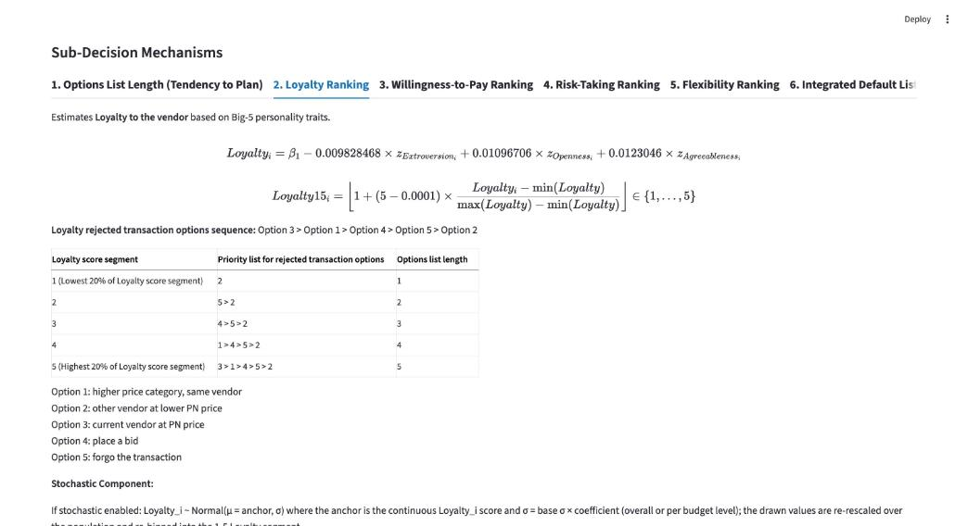
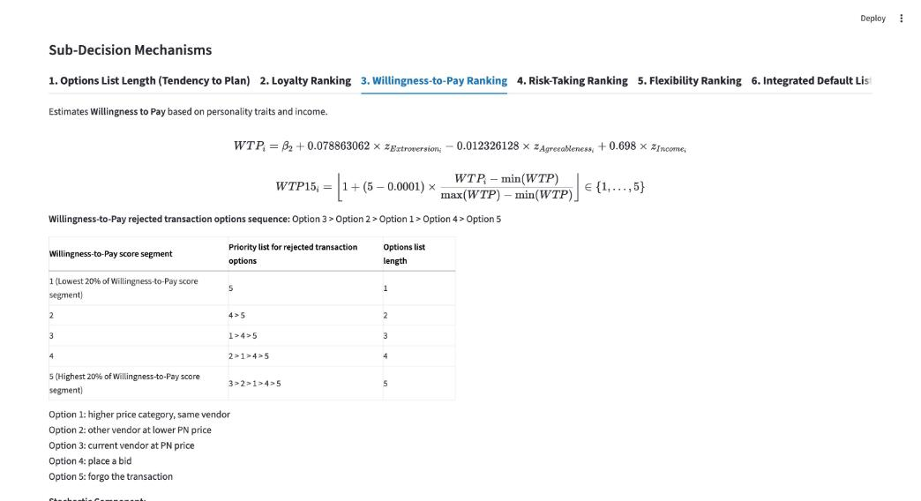
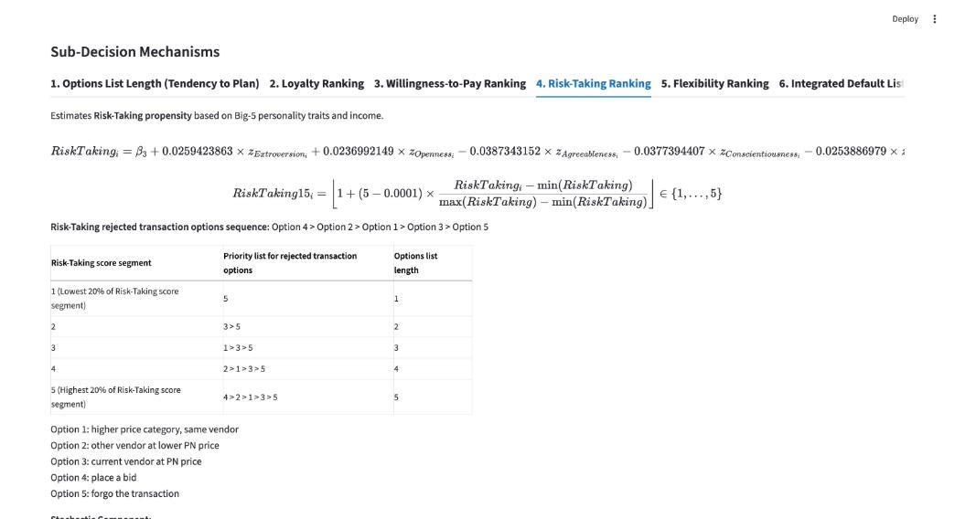
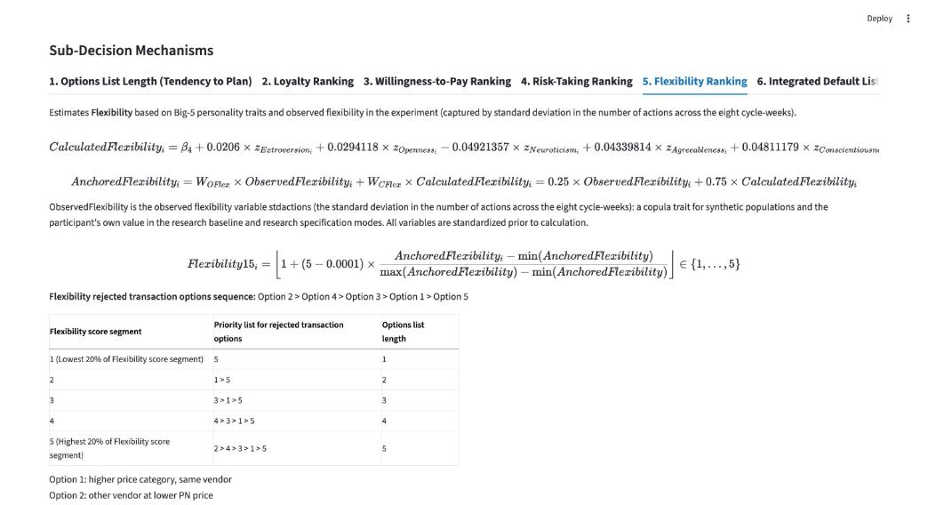
The equations and every coefficient match the document.

Step 3: Options List Length (Tendency to Plan) – F1, F2
Settings: Research Baseline, 280 agents, β0 = 0 (the app default 0.05 shifts the score by +0.05 and, with the app's fixed-cutoff semantics, the allocation; the Stata file has no intercept). Income specification irrelevant (no income term).
gen weighted_ttp = (-0.0152556564 * z_extraversionbig5) + (0.0177638642 * z_agreeable) + (0.01959 * z_neuroticismbig5) + (0.00901465 * z_conscientiousnessbig5) + (0.0297 * reducation)
summarize weighted_ttp
histogram weighted_ttp
Variable | Stata Obs | Stata Mean | Stata SD | Stata Min | Stata Max | App Obs | App Mean | App SD | App Min | App Max
weighted_ttp | 280 | 0.01124357 | 0.03528479 | −0.07178839 | 0.1379994 | 280 | 0.01124358 | 0.03528479 | −0.07178839 | 0.1379994

Stata (design document, accepted changes) | App (HEAD d202e00, Chrome capture)
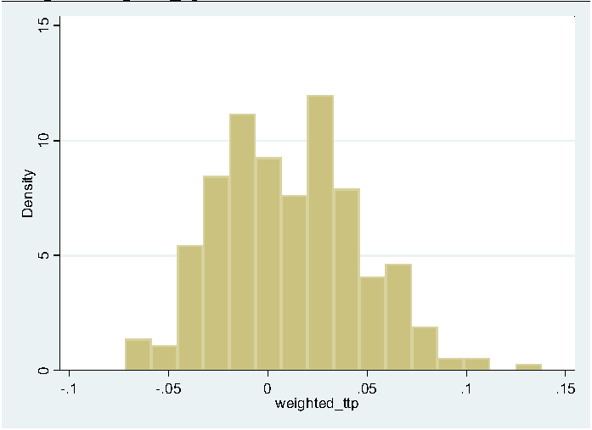 | 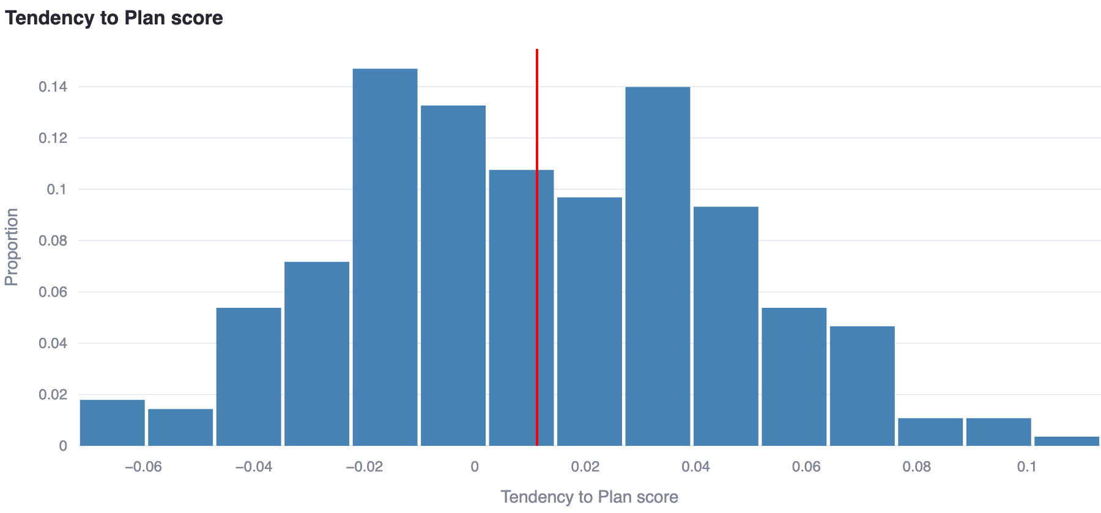

gen weighted_ttp06 = (6-0.0001)*((weighted_ttp - min_weighted_ttp)/(max_weighted_ttp - min_weighted_ttp))
gen choice_length_deterministic = floor(weighted_ttp06)
Variable | Stata Obs | Stata Mean | Stata SD | Stata Min | Stata Max | App Obs | App Mean | App SD | App Min | App Max
choice_length_deterministic | 280 | 1.853571 | 1.031748 | 0 | 5 | 280 | 1.853571 | 1.031748 | 0 | 5

Category | Stata count | Stata % | App count | App % | Equal
options 0 | 20 | 7.1% | 20 | 7.1% | yes
options 1 | 92 | 32.9% | 92 | 32.9% | yes
options 2 | 95 | 33.9% | 95 | 33.9% | yes
options 3 | 57 | 20.4% | 57 | 20.4% | yes
options 4 | 14 | 5.0% | 14 | 5.0% | yes
options 5 | 2 | 0.7% | 2 | 0.7% | yes

Stata (design document, accepted changes) | App (HEAD d202e00, Chrome capture)
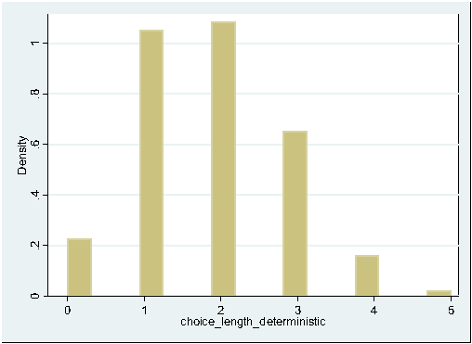 | 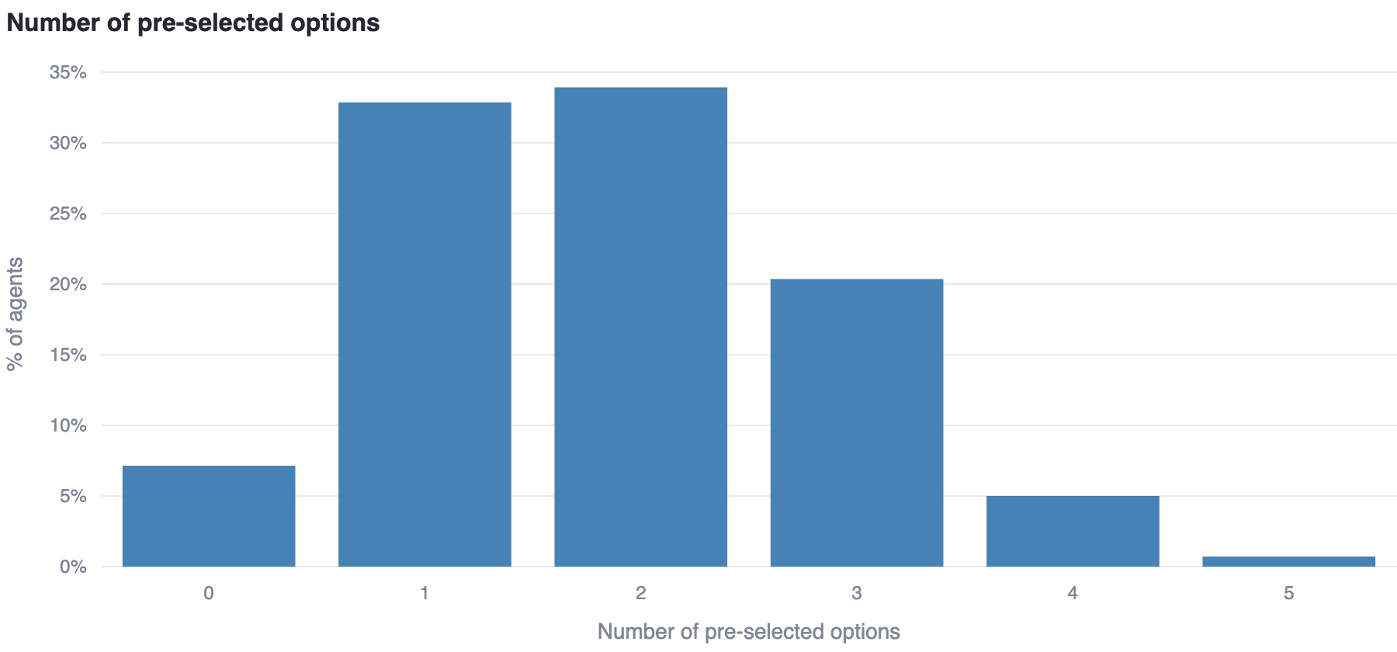

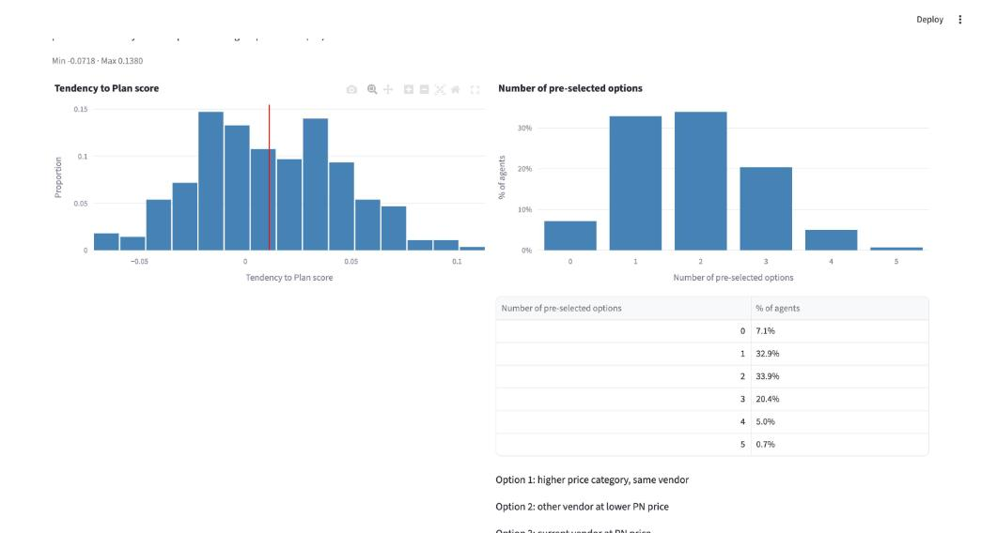
The values match exactly: weighted_ttp agrees for 280/280 participants (max |diff| 1.8e-08) and choice_length_deterministic for 280/280; the 17-bin histograms and the 0–5 allocation are identical (Stata plots density, the app the proportion).

Step 4: Loyalty ranking – F3, F4
Settings as in step 3 (β1 = 0; no income term).
gen bs_weighted_loyalty = -0.009828468*z_extraversionbig5 + 0.01096706*z_opennessbig5 + 0.0123046*z_agreeable
egen weighted_loyalty = std(bs_weighted_loyalty)
replace weighted_loyalty = weighted_loyalty + beta1
summarize weighted_loyalty
histogram weighted_loyalty
Variable | Stata Obs | Stata Mean | Stata SD | Stata Min | Stata Max | App Obs | App Mean | App SD | App Min | App Max
weighted_loyalty | 280 | −1.250633e‑09 | 1 | −3.141984 | 3.93632 | 280 | −3.806479e‑17 | 1 | −3.141984 | 3.93632

Stata (design document, accepted changes) | App (HEAD d202e00, Chrome capture)
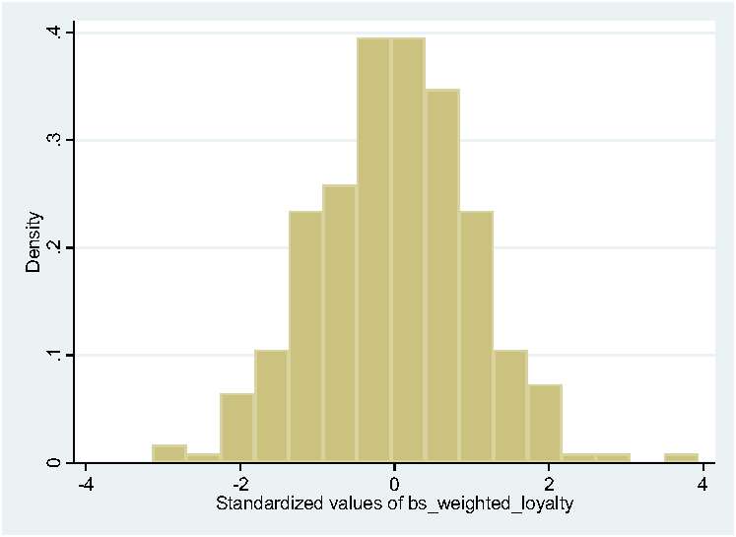 | 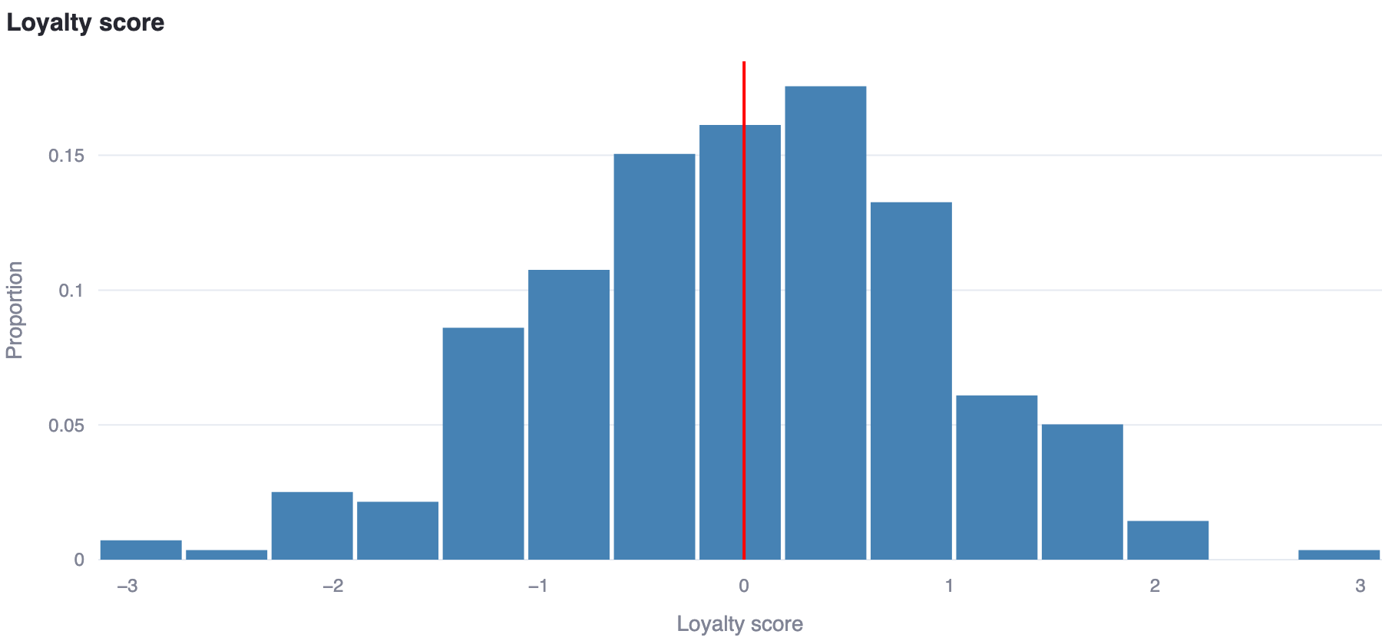

gen weighted_loyalty15 = floor(1+(5-0.0001)*((weighted_loyalty - min_weighted_loyalty)/(max_weighted_loyalty - min_weighted_loyalty)))
summarize weighted_loyalty15
histogram weighted_loyalty15
replace choice1_loyalty_deterministic = 2 if weighted_loyalty15 == 1 ... = 3 if weighted_loyalty15 == 5
The app chart shows the FIRST option of each agent's loyalty list, with the x-axis in reversed priority order (2, 5, 4, 1, 3) – i.e. exactly segments 1…5 of weighted_loyalty15 relabelled with their first option:
Variable | Stata Obs | Stata Mean | Stata SD | Stata Min | Stata Max | App Obs | App Mean | App SD | App Min | App Max
weighted_loyalty15 | 280 | 2.728571 | 0.74143 | 1 | 5 | 280 | 2.728571 | 0.74143 | 1 | 5

Category | Stata count | Stata % | App count | App % | Equal
segment 1 | 12 | 4.3% | 12 | 4.3% | yes
segment 2 | 87 | 31.1% | 87 | 31.1% | yes
segment 3 | 148 | 52.9% | 148 | 52.9% | yes
segment 4 | 31 | 11.1% | 31 | 11.1% | yes
segment 5 | 2 | 0.7% | 2 | 0.7% | yes

Category | Stata count | Stata % | App count | App % | Equal
first option 1 | 31 | 11.1% | 31 | 11.1% | yes
first option 2 | 12 | 4.3% | 12 | 4.3% | yes
first option 3 | 2 | 0.7% | 2 | 0.7% | yes
first option 4 | 148 | 52.9% | 148 | 52.9% | yes
first option 5 | 87 | 31.1% | 87 | 31.1% | yes

Stata (design document, accepted changes) | App (HEAD d202e00, Chrome capture)
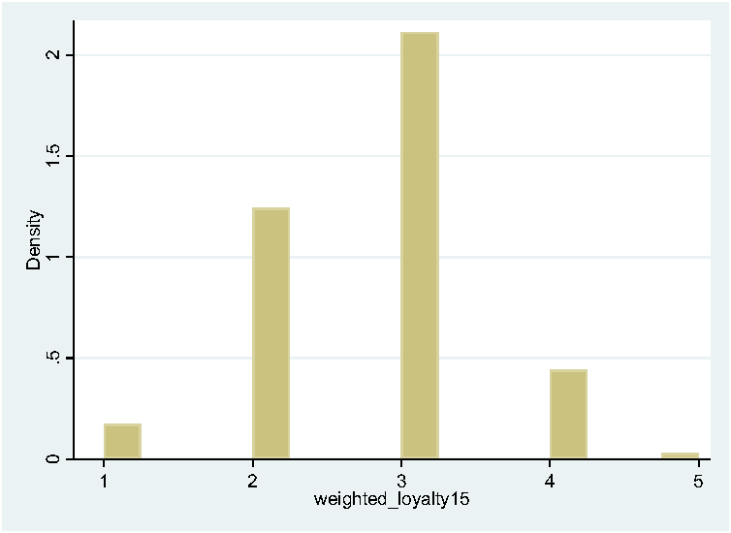 | 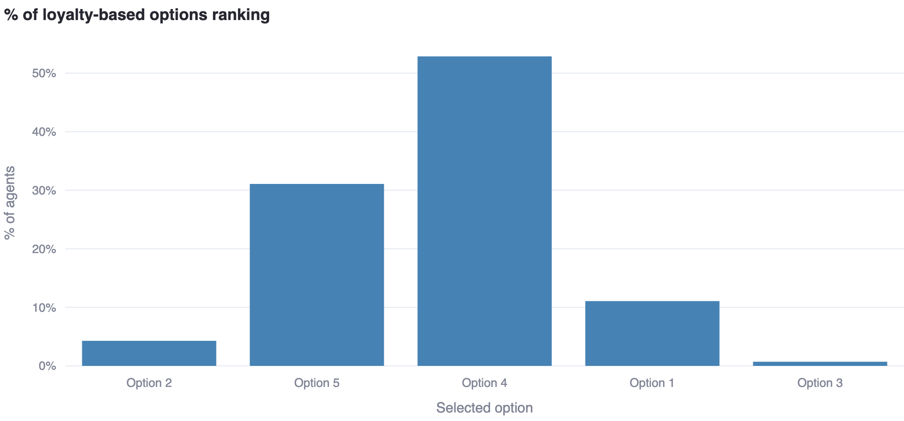

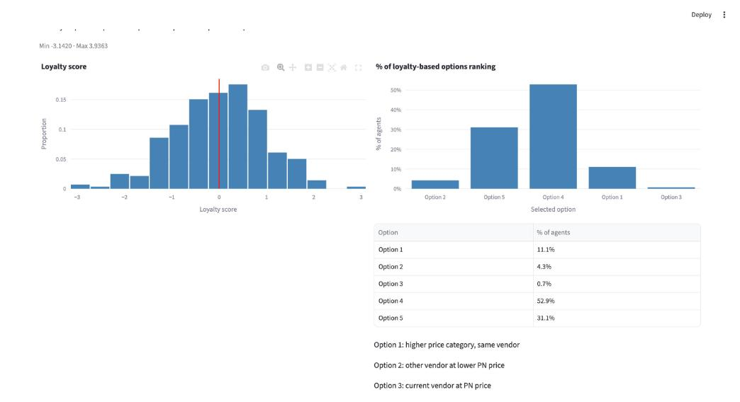
The values match exactly: weighted_loyalty 280/280 (max |diff| 3.2e-07), weighted_loyalty15 280/280, and the five-position choice lists choice1…choice5_loyalty_deterministic 280/280.

Step 5: Willingness-to-Pay ranking, continuous income – F6, F8
Settings as in step 3 with Income Specification = Continuous only (β2 = 0).
gen WTP_calculated = 0.078863062 * z_extraversionbig5 - 0.012326128* z_agreeable + 0.698 * z_net_income
egen z_WTP_calculated= std(WTP_calculated)
replace z_WTP_calculated = z_WTP_calculated + beta2
summarize z_WTP_calculated
histogram z_WTP_calculated
Variable | Stata Obs | Stata Mean | Stata SD | Stata Min | Stata Max | App Obs | App Mean | App SD | App Min | App Max
z_WTP_calculated | 280 | 1.736251e‑09 | 1 | −1.397873 | 5.470183 | 280 | −1.268826e‑17 | 1 | −1.397877 | 5.470187

Stata (design document, accepted changes) | App (HEAD d202e00, Chrome capture)
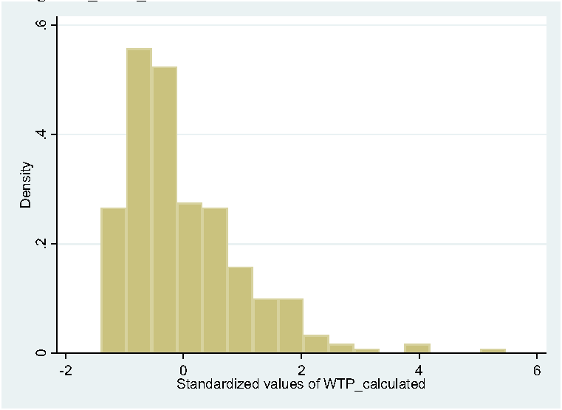 | 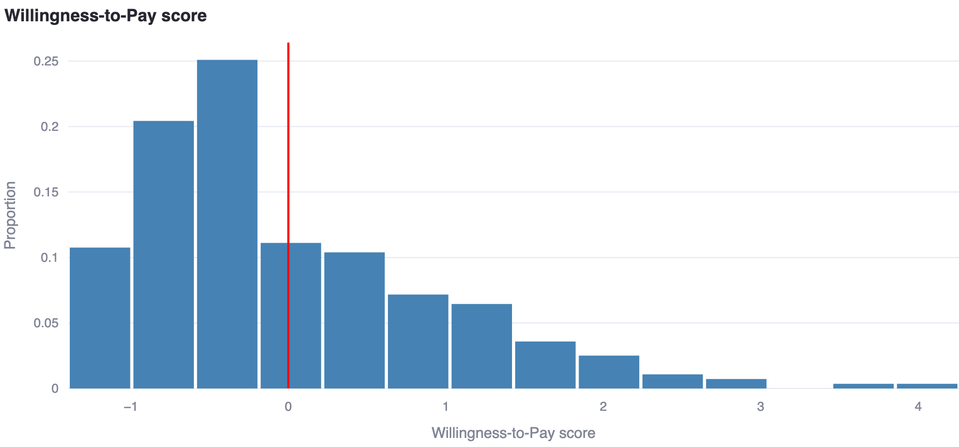

gen WTP_calculated15 = floor(1+(5-0.0001)*(( z_WTP_calculated - min_WTP_calculated)/( max_WTP_calculated - min_WTP_calculated)))
histogram WTP_calculated15
Variable | Stata Obs | Stata Mean | Stata SD | Stata Min | Stata Max | App Obs | App Mean | App SD | App Min | App Max
WTP_calculated15 | 280 | 1.525 | 0.7376826 | 1 | 5 | 280 | 1.525 | 0.7376826 | 1 | 5

Category | Stata count | Stata % | App count | App % | Equal
segment 1 | 168 | 60.0% | 168 | 60.0% | yes
segment 2 | 82 | 29.3% | 82 | 29.3% | yes
segment 3 | 26 | 9.3% | 26 | 9.3% | yes
segment 4 | 3 | 1.1% | 3 | 1.1% | yes
segment 5 | 1 | 0.4% | 1 | 0.4% | yes

Category | Stata count | Stata % | App count | App % | Equal
first option 1 | 26 | 9.3% | 26 | 9.3% | yes
first option 2 | 3 | 1.1% | 3 | 1.1% | yes
first option 3 | 1 | 0.4% | 1 | 0.4% | yes
first option 4 | 82 | 29.3% | 82 | 29.3% | yes
first option 5 | 168 | 60.0% | 168 | 60.0% | yes

Stata (design document, accepted changes) | App (HEAD d202e00, Chrome capture)
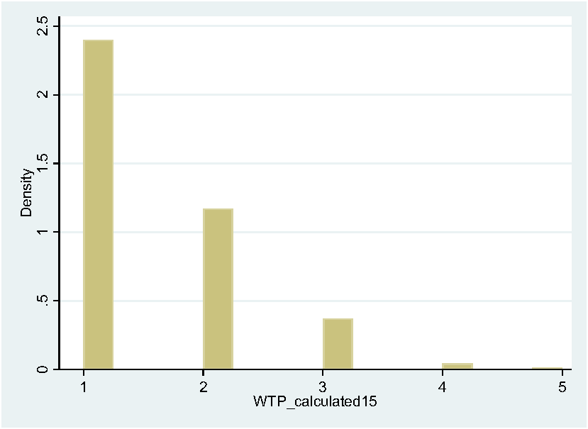 | 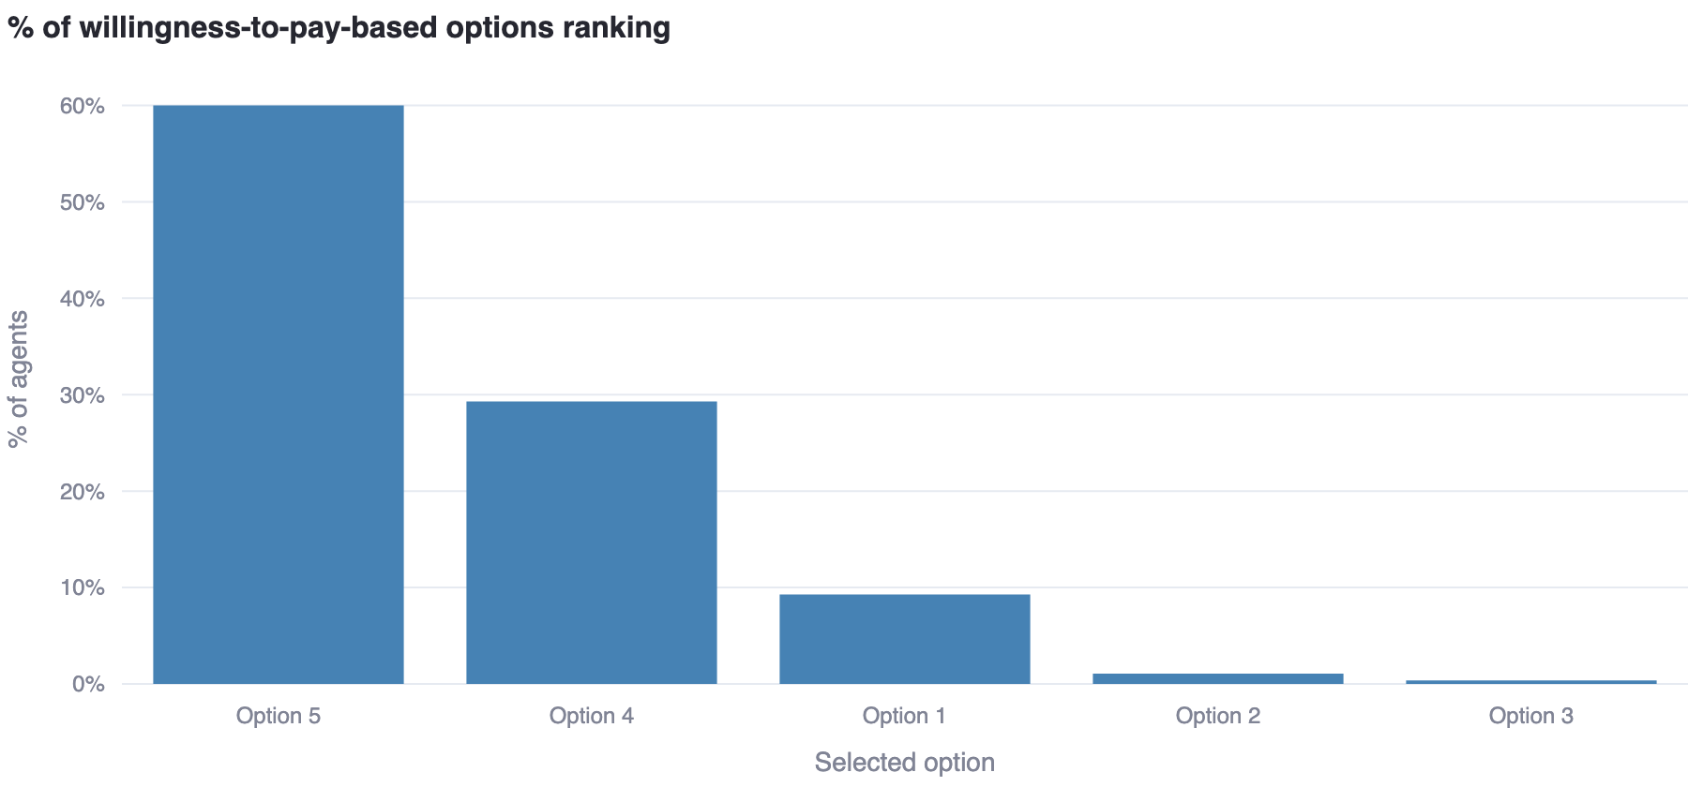

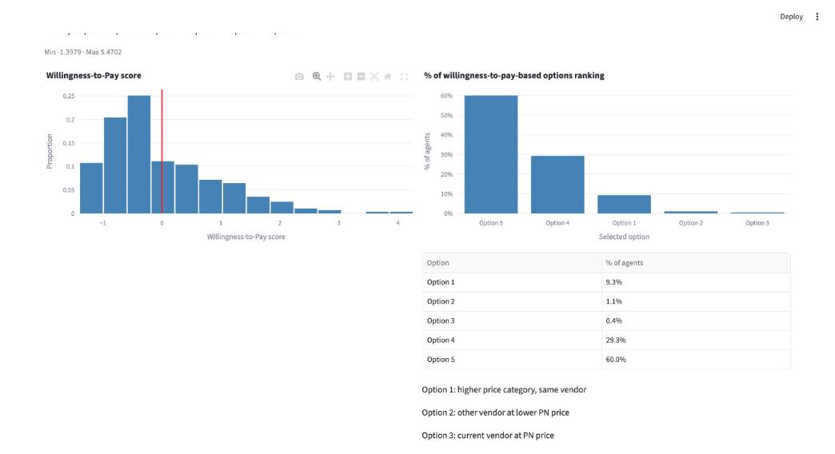
The values match exactly: z_WTP_calculated 280/280 (max |diff| 8.1e-06, the .dta stores float32), WTP_calculated15 280/280, choice lists 280/280.

Step 6: Willingness-to-Pay ranking, categorical income – T1, F5, F7
Settings as in step 3 with Income Specification = Categorical only (β2 = 0).
regress WTP_calculated WTP_noincome i.totalallowance
WTP_noincome .5439353 | 32 .2671588 | 72 .5057716 | 128 .9411747 | 200 1.822471 | _cons -.691843
gen weighted_WTP_categorical = cond(assignedallowancelevel ==5, 1.822471-0.691843 + 0.078863062 * z_extraversionbig5 - 0.012326128 * z_agreeable, cond(... ==4, 0.9411747-0.691843 + ..., cond(... ==3, 0.5057716-0.691843 + ..., cond(... ==2, 0.2671588-0.691843 + ..., -0.691843 + 0.078863062 * z_extraversionbig5 - 0.012326128 * z_agreeable))))
egen z_WTP_categorical = std(weighted_WTP_categorical)
replace z_WTP_categorical = z_WTP_categorical+ beta2
The regression table's level effects appear in the app as the "Income Quintile Effects (β_income_q)" table (base intercept + level dummy):
Quintile | Stata (regress, document) | App β_income_q | Equal
Q1 (€12) | -.691843 | −0.6918430 | yes
Q2 (€32) | -.691843 + .2671588 = -.4246842 | −0.4246842 | yes
Q3 (€72) | -.691843 + .5057716 = -.1860714 | −0.1860714 | yes
Q4 (€128) | -.691843 + .9411747 = .2493317 | 0.2493317 | yes
Q5 (€200) | -.691843 + 1.822471 = 1.130628 | 1.1306280 | yes

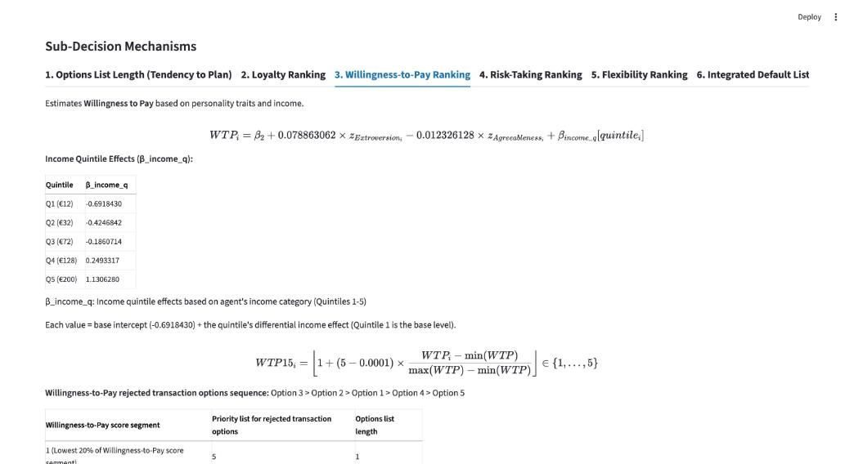
Stata figures F5 (raw weighted_WTP_categorical) and F7 (standardised) vs the app's categorical WTP score (the app charts the standardised score; F5 is the same histogram on the raw scale):
Stata F5 – raw weighted_WTP_categorical | Stata F7 – z_WTP_categorical
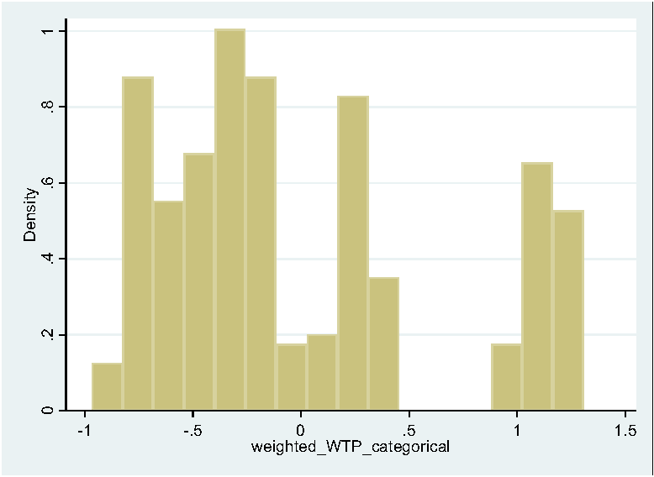 | 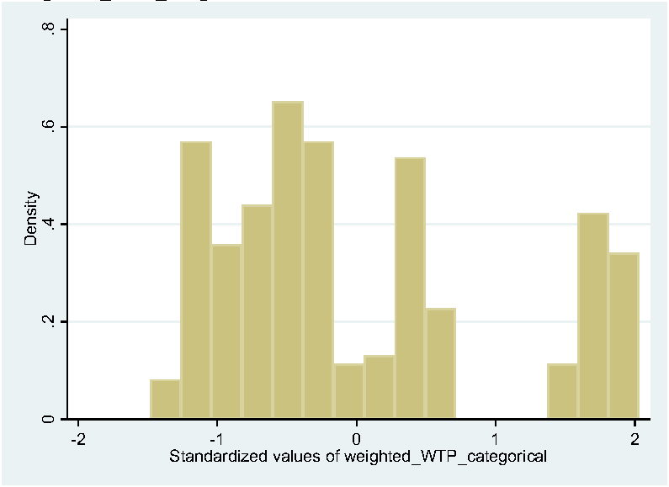

App – WTP score, Categorical only | App – WTP-based options ranking, Categorical only
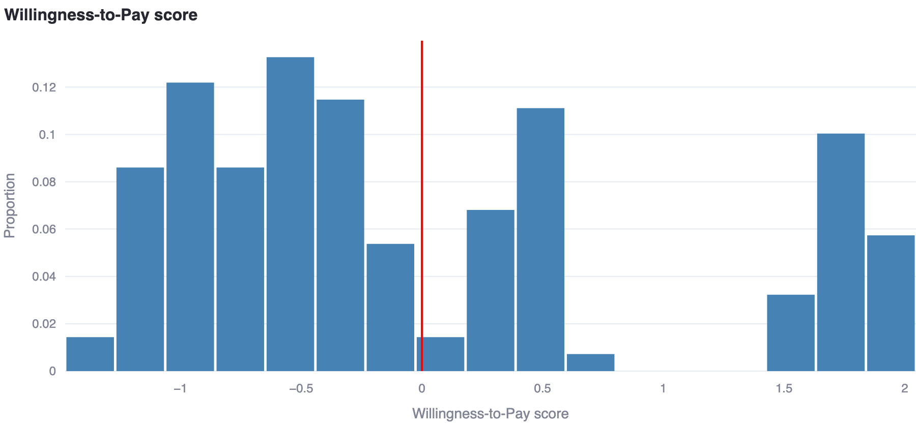 | 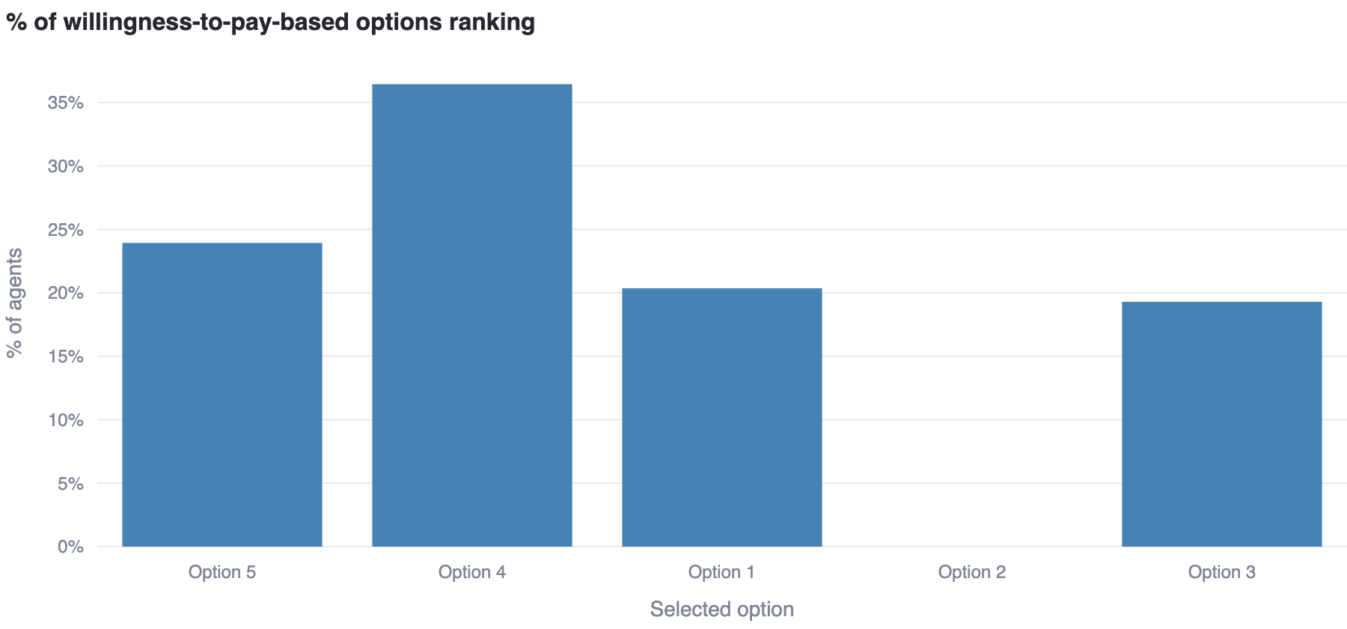

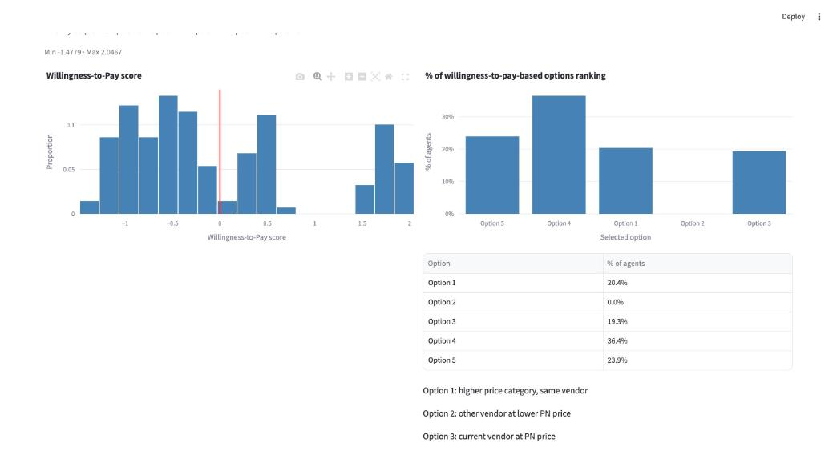
Variable | Stata Obs | Stata Mean | Stata SD | Stata Min | Stata Max | App Obs | App Mean | App SD | App Min | App Max
z_WTP_categorical (.dta) | 280 | −2.328306e‑10 | 1 | −1.480752 | 2.029977 | 280 | 3.172066e‑18 | 1 | −1.477873 | 2.04668
weighted_WTP_categorical (.dta, raw) | 280 | −0.00869533 | 0.6477116 | −0.9677956 | 1.306144 | 280 | −4.3748e‑08 | 0.6381788 | −0.9431473 | 1.306148

Finding (document / .dta error, not an app defect). The app evaluates the document's printed cond() code exactly (max |diff| 9e-09 against a direct re-computation of that code on the .dta z-columns), but the column weighted_WTP_categorical STORED in Stata_File_Decision4_050926.dta was generated with a superseded version of that command: for allowance levels 2–5 it uses the agreeableness coefficient −0.0123242128 (the value the tracked changes of rev 040926-2 deleted in favour of −0.012326128), and for level 1 (57 participants) a different intercept and coefficient altogether (fitted exactly: −0.7355455 + 0.078863062·zE − 0.0046002694·zA, instead of −0.691843 + 0.078863062·zE − 0.012326128·zA). Consequently the .dta's z_WTP_categorical differs from the document's own formula by up to 0.062 (z-units), its min/max are −1.480752 / 2.029977 versus −1.477873 / 2.046680 for the printed code, and the F7 histogram above is the histogram of the superseded column. The segment allocation differs for exactly 1 of 280 participants (Stata-stored column: 67/101/58/0/54; document code = app: 67/102/57/0/54). The app follows the written document; the professor may want to regenerate the .dta column with the current cond() command.
Category | Stata count | Stata % | App count | App % | Equal
segment (Stata-stored column vs app) 1 | 67 | 23.9% | 67 | 23.9% | yes
segment (Stata-stored column vs app) 2 | 101 | 36.1% | 102 | 36.4% | NO
segment (Stata-stored column vs app) 3 | 58 | 20.7% | 57 | 20.4% | NO
segment (Stata-stored column vs app) 4 | 0 | 0.0% | 0 | 0.0% | yes
segment (Stata-stored column vs app) 5 | 54 | 19.3% | 54 | 19.3% | yes

The coefficients match the document exactly; the app reproduces the document's categorical WTP code to 1e-08. The stored .dta column is the only mismatch (superseded formula in the file, 1 agent's segment).

Step 7: Risk-Taking ranking, continuous income – F9, F12
Settings as in step 5 (β3 = 0, Continuous only).
gen RT_calculated_hs = 0.025942386297 * z_extraversionbig5 + 0.023699214948 * z_opennessbig5 - 0.038734315188 * z_agreeable - 0.037739440732 * z_conscientiousnessbig5 - 0.025388697852 * z_neuroticismbig5 + 0.006874197106 * z_net_income
egen z_RT_calculated_hs = std(RT_calculated_hs)
replace z_RT_calculated_hs = z_RT_calculated_hs + beta3
histogram z_RT_calculated_hs
Variable | Stata Obs | Stata Mean | Stata SD | Stata Min | Stata Max | App Obs | App Mean | App SD | App Min | App Max
z_RT_calculated_hs | 280 | −8.421401e‑10 | 1 | −2.646594 | 3.333153 | 280 | −2.854859e‑17 | 1 | −2.646594 | 3.333153

Stata (design document, accepted changes) | App (HEAD d202e00, Chrome capture)
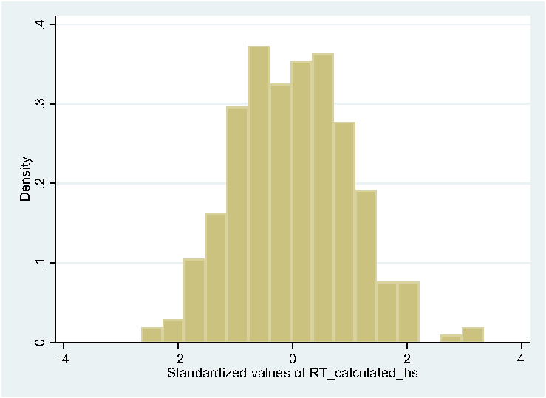 | 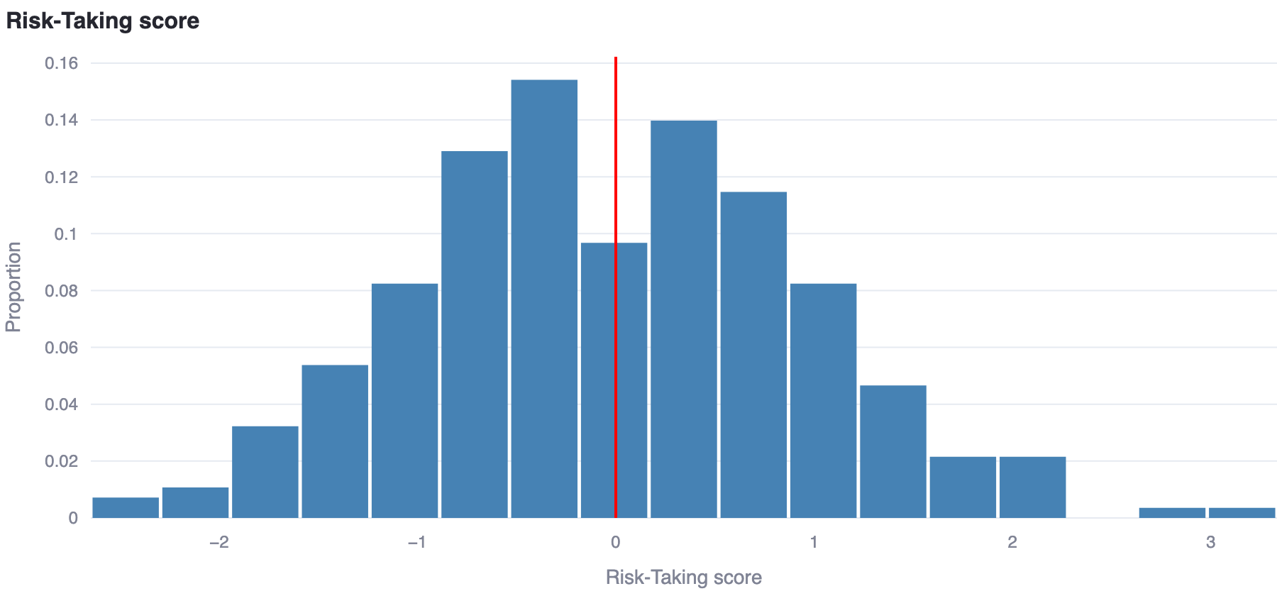

gen RT_calculated15 = floor(1+(5-0.0001)*((z_RT_calculated_hs - min_RT_calculated)/(max_RT_calculated - min_RT_calculated)))
histogram RT_calculated15
Variable | Stata Obs | Stata Mean | Stata SD | Stata Min | Stata Max | App Obs | App Mean | App SD | App Min | App Max
RT_calculated15 | 280 | 2.692857 | 0.8790385 | 1 | 5 | 280 | 2.692857 | 0.8790385 | 1 | 5

Category | Stata count | Stata % | App count | App % | Equal
segment 1 | 20 | 7.1% | 20 | 7.1% | yes
segment 2 | 100 | 35.7% | 100 | 35.7% | yes
segment 3 | 110 | 39.3% | 110 | 39.3% | yes
segment 4 | 46 | 16.4% | 46 | 16.4% | yes
segment 5 | 4 | 1.4% | 4 | 1.4% | yes

Category | Stata count | Stata % | App count | App % | Equal
first option 1 | 110 | 39.3% | 110 | 39.3% | yes
first option 2 | 46 | 16.4% | 46 | 16.4% | yes
first option 3 | 100 | 35.7% | 100 | 35.7% | yes
first option 4 | 4 | 1.4% | 4 | 1.4% | yes
first option 5 | 20 | 7.1% | 20 | 7.1% | yes

Stata (design document, accepted changes) | App (HEAD d202e00, Chrome capture)
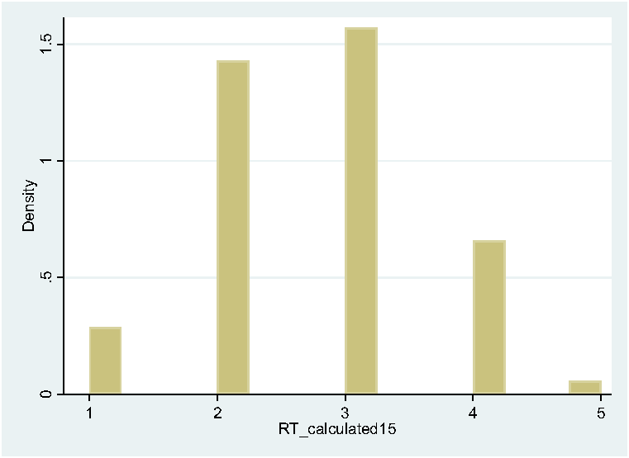 | 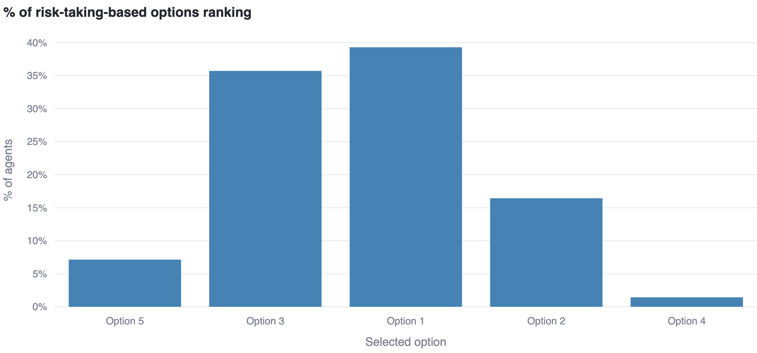

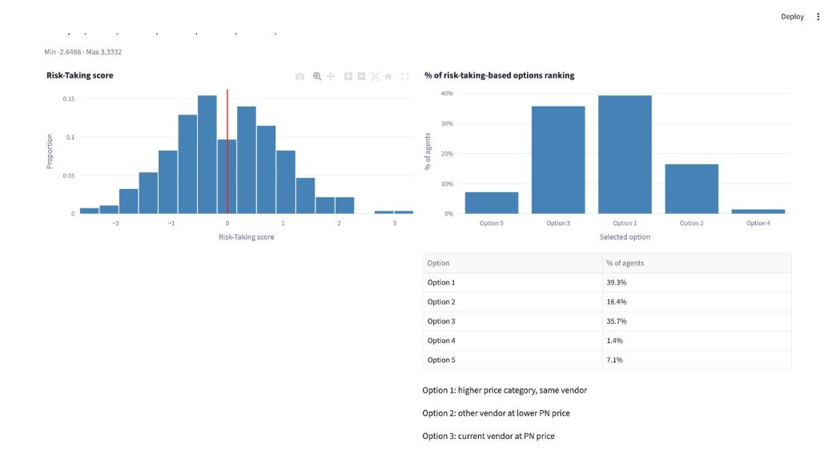
The values match exactly: z_RT_calculated_hs 280/280 (max |diff| 1.7e-07), RT_calculated15 280/280, choice lists 280/280.

Step 8: Risk-Taking ranking, categorical income – T2, F10, F11
Settings as in step 6 (β3 = 0, Categorical only).
regress RT_calculated_hs RT_noincome_hs i.totalallowance
32 .0026128 | 72 .0050555 | 128 .0092738 | 200 .0179812 | _cons -.0068307
gen weighted_RT_categorical = cond(assignedallowancelevel ==5, 0.0179812-0.0068307 + ..., cond(... ==4, 0.0092738-0.0068307 + ..., cond(... ==3, 0.0050555-0.0068307 + ..., cond(... ==2, 0.0026128-0.0068307 + ..., -0.0068307 + ...))))
egen z_RT_categorical = std(weighted_RT_categorical)
replace z_RT_categorical = z_RT_categorical+ beta3
Quintile | Stata (regress, document) | App β_income_q | Equal
Q1 (€12) | -.0068307 | −0.0068307 | yes
Q2 (€32) | -.0068307 + .0026128 = -.0042179 | −0.0042179 | yes
Q3 (€72) | -.0068307 + .0050555 = -.0017752 | −0.0017752 | yes
Q4 (€128) | -.0068307 + .0092738 = .0024431 | 0.0024431 | yes
Q5 (€200) | -.0068307 + .0179812 = .0111505 | 0.0111505 | yes

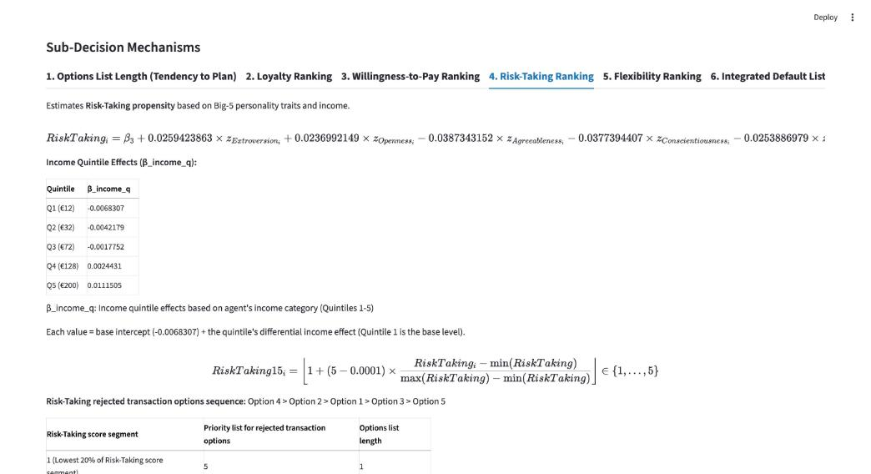
Stata F10 – raw weighted_RT_categorical | Stata F11 – z_RT_categorical
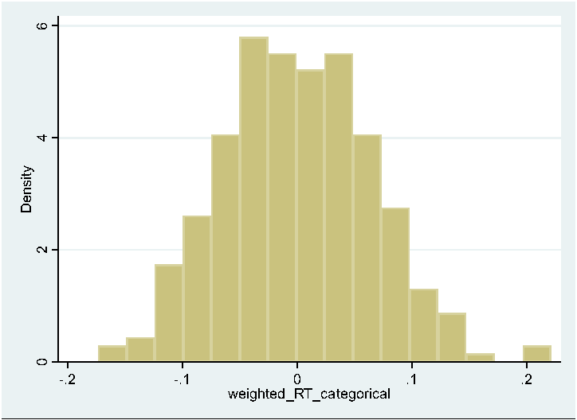 | 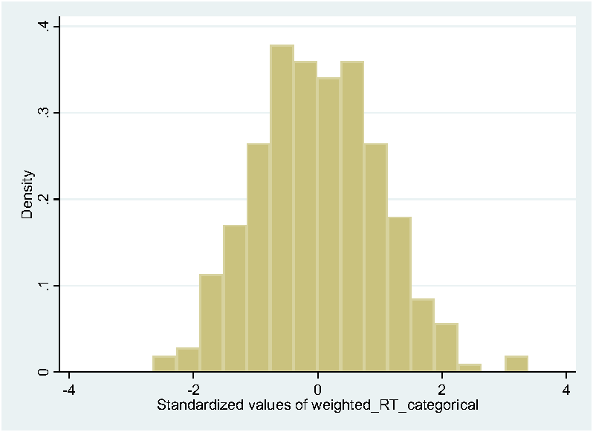

App – Risk-Taking score, Categorical only | App – RT-based options ranking, Categorical only
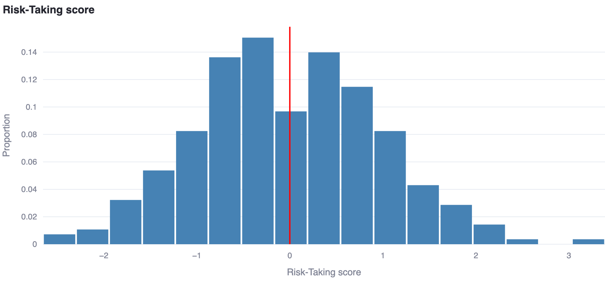 | 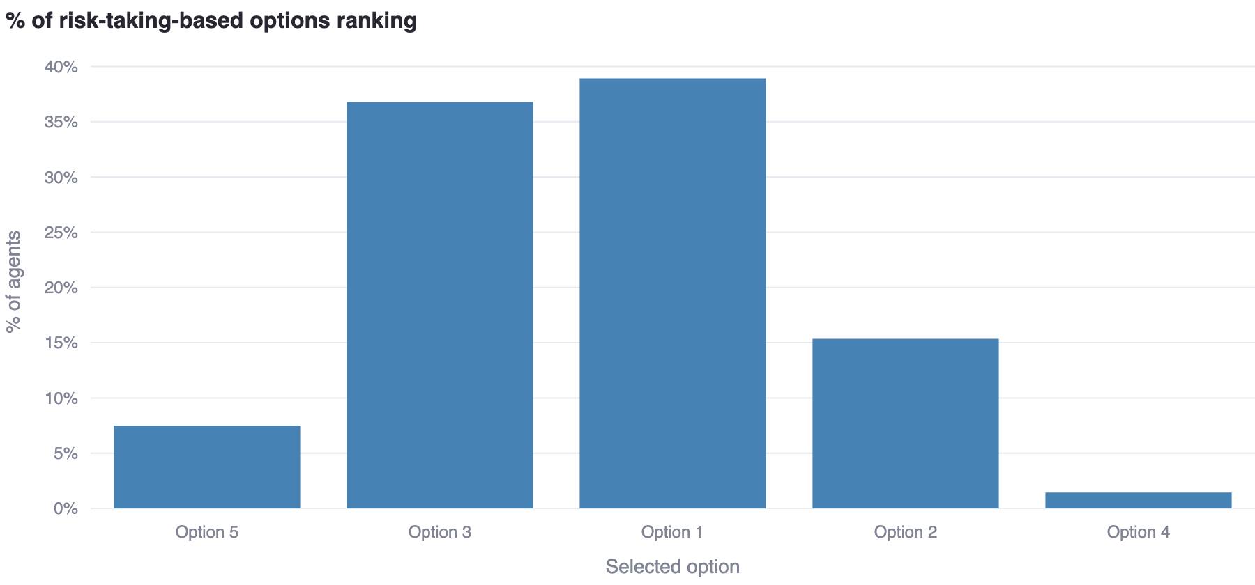

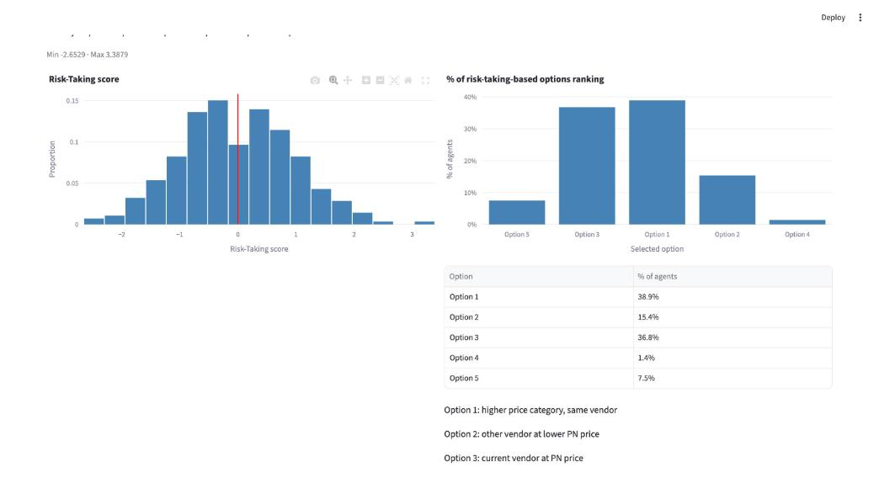
Variable | Stata Obs | Stata Mean | Stata SD | Stata Min | Stata Max | App Obs | App Mean | App SD | App Min | App Max
z_RT_categorical | 280 | 8.53158e‑10 | 1 | −2.652918 | 3.387871 | 280 | 9.516197e‑18 | 1 | −2.652918 | 3.387871
weighted_RT_categorical (raw) | 280 | −4.175324e‑08 | 0.06530878 | −0.1732589 | 0.2212577 | 280 | −5.230291e‑08 | 0.06530878 | −0.1732589 | 0.2212577

The document stores no categorical RT segments; applying its floor rule to the .dta's z_RT_categorical gives 21/103/109/43/4, identical to the app's categorical RT segments.
Category | Stata count | Stata % | App count | App % | Equal
segment (floor rule on .dta vs app) 1 | 21 | 7.5% | 21 | 7.5% | yes
segment (floor rule on .dta vs app) 2 | 103 | 36.8% | 103 | 36.8% | yes
segment (floor rule on .dta vs app) 3 | 109 | 38.9% | 109 | 38.9% | yes
segment (floor rule on .dta vs app) 4 | 43 | 15.4% | 43 | 15.4% | yes
segment (floor rule on .dta vs app) 5 | 4 | 1.4% | 4 | 1.4% | yes

The values match exactly: z_RT_categorical 280/280 (max |diff| 2.0e-07); floor-rule segments 280/280.

Step 9: Flexibility ranking – F13, F14, F15, F16
Settings as in step 3 (β4 = 0, W_OFlex = 0.25; no income term).
gen Flexibility_calculated_ivw = 0.0206 * z_extraversionbig5 + 0.0294118 * z_opennessbig5 - 0.04921357 * z_neuroticismbig5 + 0.04339814 * z_agreeable + 0.04811179 * z_conscientiousnessbig5
egen z_Flexibility_calculated_ivw = std(Flexibility_calculated_ivw)
replace z_Flexibility_calculated_ivw = z_Flexibility_calculated_ivw + beta4
histogram z_Flexibility_calculated_ivw
egen z_stdactions = std(stdactions)
histogram z_stdactions
gen anchored_flexibility = 0.25*z_stdactions + 0.75 * z_Flexibility_calculated_ivw
egen z_anchored_flexibility = std(anchored_flexibility)
histogram z_anchored_flexibility
F13 and F14 are intermediate variables that the app does not chart; they are compared through the app's export columns (rtd_flex_z_ivw, rtd_z_stdactions). F15 is the app's "Flexibility score" chart.
Variable | Stata Obs | Stata Mean | Stata SD | Stata Min | Stata Max | App Obs | App Mean | App SD | App Min | App Max
z_Flexibility_calculated_ivw | 280 | 8.764411e‑10 | 1 | −2.994517 | 3.338073 | 280 | 1.268826e‑17 | 1 | −2.994517 | 3.338074
z_stdactions (.dta: z_stdactionsP) | 280 | 5.554674e‑09 | 1 | −1.756797 | 5.835501 | 280 | 4.165653e‑08 | 1 | −1.756797 | 5.835501
z_anchored_flexibility | 280 | 3.891598e‑10 | 1 | −2.970918 | 3.623505 | 280 | −2.854859e‑17 | 1 | −2.970918 | 3.623505

Stata F13 – z_Flexibility_calculated_ivw (export column rtd_flex_z_ivw) | Stata F14 – z_stdactions (export column rtd_z_stdactions)
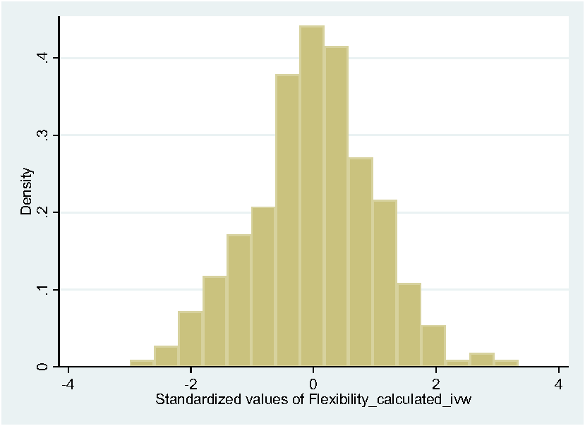 | 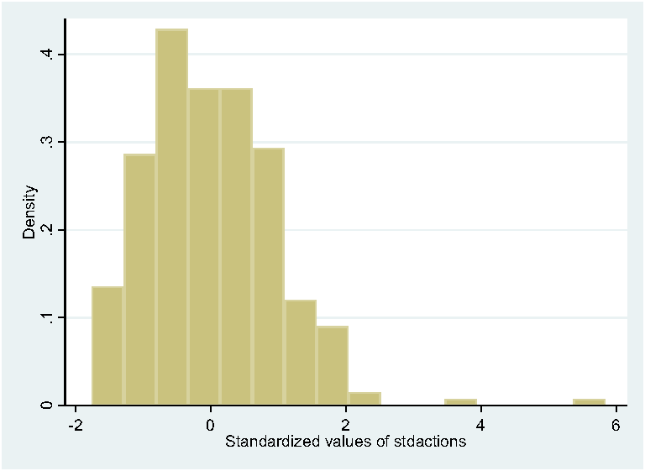

Stata (design document, accepted changes) | App (HEAD d202e00, Chrome capture)
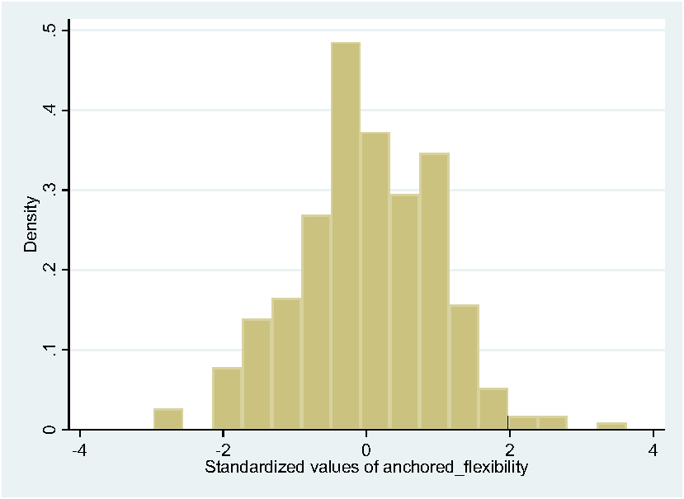 | 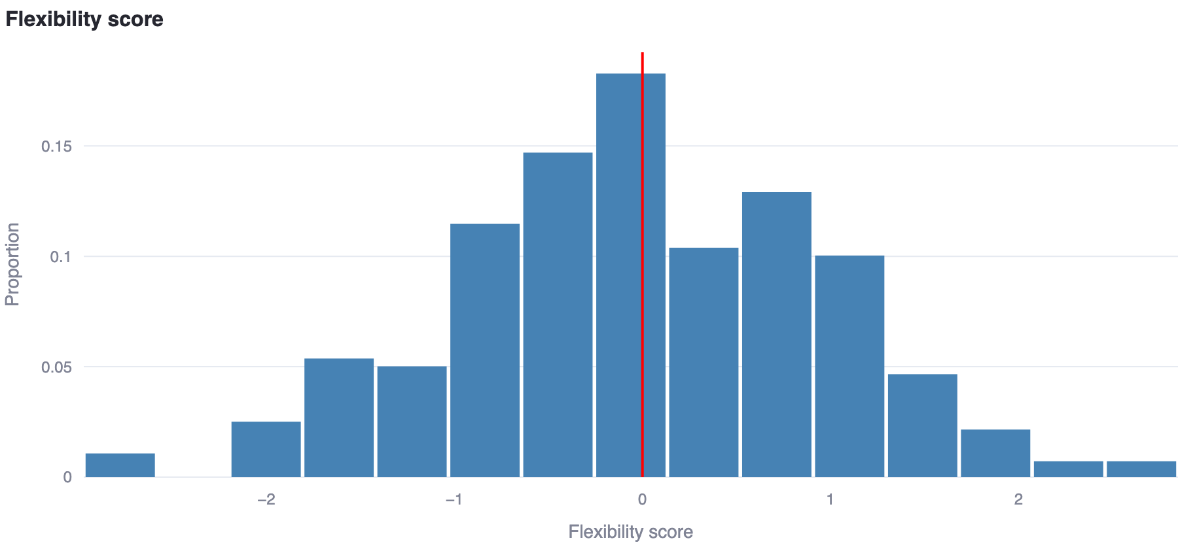

gen Flexibility_combined15 = floor(1+(5-0.0001)*((z_anchored_flexibility- min_Flexibility_combined)/(max_Flexibility_combined - min_Flexibility_combined)))
histogram Flexibility_combined15
Variable | Stata Obs | Stata Mean | Stata SD | Stata Min | Stata Max | App Obs | App Mean | App SD | App Min | App Max
Flexibility_combined15 | 280 | 2.735714 | 0.817468 | 1 | 5 | 280 | 2.735714 | 0.817468 | 1 | 5

Category | Stata count | Stata % | App count | App % | Equal
segment 1 | 17 | 6.1% | 17 | 6.1% | yes
segment 2 | 85 | 30.4% | 85 | 30.4% | yes
segment 3 | 137 | 48.9% | 137 | 48.9% | yes
segment 4 | 37 | 13.2% | 37 | 13.2% | yes
segment 5 | 4 | 1.4% | 4 | 1.4% | yes

Category | Stata count | Stata % | App count | App % | Equal
first option 1 | 85 | 30.4% | 85 | 30.4% | yes
first option 2 | 4 | 1.4% | 4 | 1.4% | yes
first option 3 | 137 | 48.9% | 137 | 48.9% | yes
first option 4 | 37 | 13.2% | 37 | 13.2% | yes
first option 5 | 17 | 6.1% | 17 | 6.1% | yes

Stata (design document, accepted changes) | App (HEAD d202e00, Chrome capture)
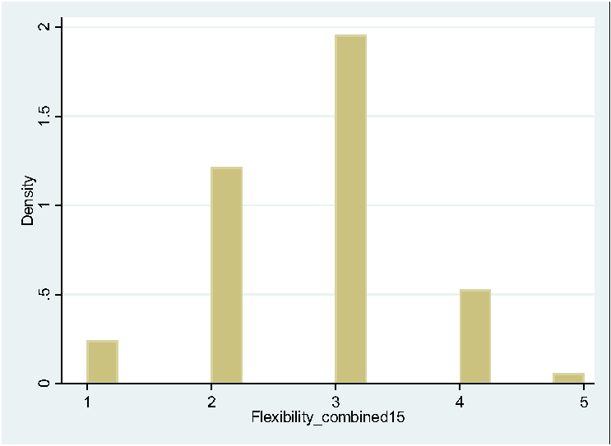 | 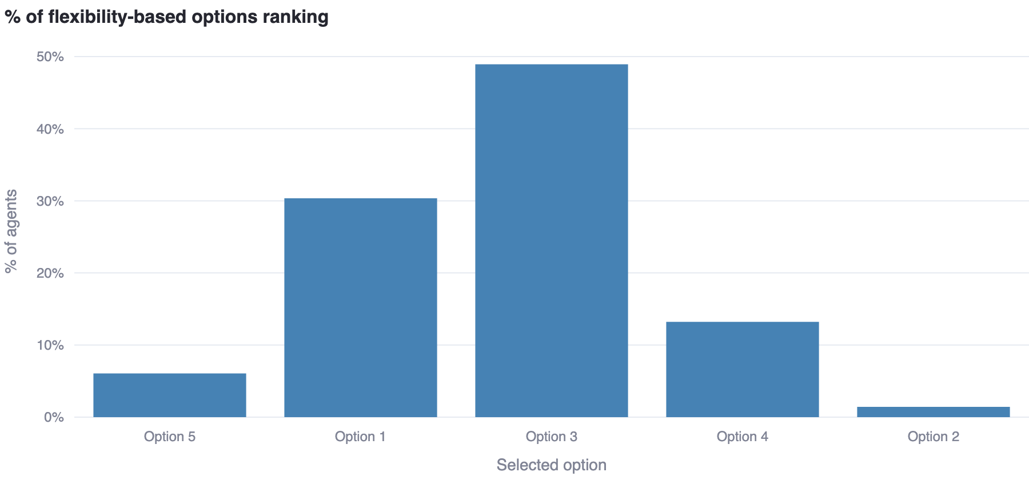

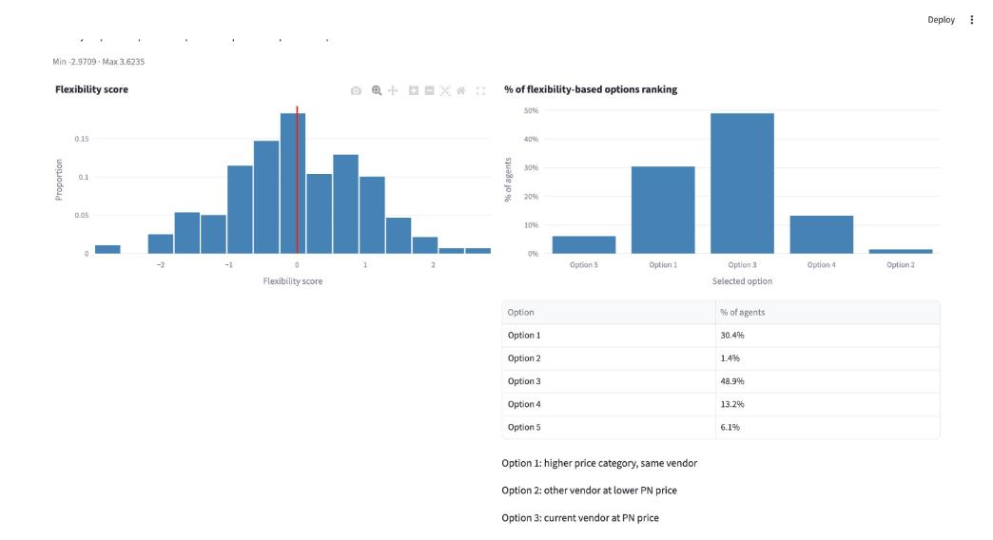
The values match exactly: z_Flexibility_calculated_ivw, z_stdactions and z_anchored_flexibility 280/280 (max |diff| ≤ 2.2e-07), Flexibility_combined15 280/280, choice lists 280/280.

Step 10: The σ tables (stochastic component constants)
The document derives, per element, σ_overall = (range/18)·mean(stdactions) and σ_quintile(q) = (range/18)·mean(stdactions within allowance group q). mean(stdactions) by total allowance from the .dta:
Total allowance | mean(stdactions) (.dta)
12 | 1.022823
32 | 1.136698
72 | 1.310647
128 | 1.225694
200 | 1.25449
Total | 1.186338

Ranges of the standardised scores (document vs .dta): weighted_loyalty 7.0783045 vs 7.078304; z_WTP_calculated 6.868056 vs 6.868057; z_RT_calculated_hs 5.979747 vs 5.979747; z_anchored_flexibility 6.5944228 vs 6.594423 (float32 storage explains the 7th-digit differences).
Element | Doc σ_overall | App base σ | Doc σ_quintile 12/32/72/128/200 | App σ per level 1–5
TTP | 0.395446 | 0.395446 | 0.340941 / 0.378899 / 0.436882 / 0.408565 / 0.418163 | 0.3409412 / 0.3788994 / 0.4368824 / 0.4085648 / 0.4181634
Loyalty | 0.4665145336 | 0.4665145 | 0.3738315395 / 0.4154515424 / 0.4790281978 / 0.4479787442 / 0.4585033149 | 0.3738315 / 0.4154515 / 0.4790282 / 0.4479787 / 0.4585033
WTP | 0.4526575455 | 0.4526575 | 0.3902671709 / 0.4337170115 / 0.5000888363 / 0.4676742829 / 0.4786615699 | 0.3902672 / 0.433717 / 0.5000888 / 0.4676743 / 0.4786616
Risk-Taking | 0.39522204 | 0.395222 | 0.33979032 / 0.37762039 / 0.43540774 / 0.40718566 / 0.41675186 | 0.3397903 / 0.3776204 / 0.4354077 / 0.4071857 / 0.4167519
Flexibility | 0.4346228732 | 0.4346229 | 0.3747183671 / 0.4164371037 / 0.4801645799 / 0.4490414678 / 0.4595910065 | 0.3747184 / 0.4164371 / 0.4801646 / 0.4490415 / 0.459591

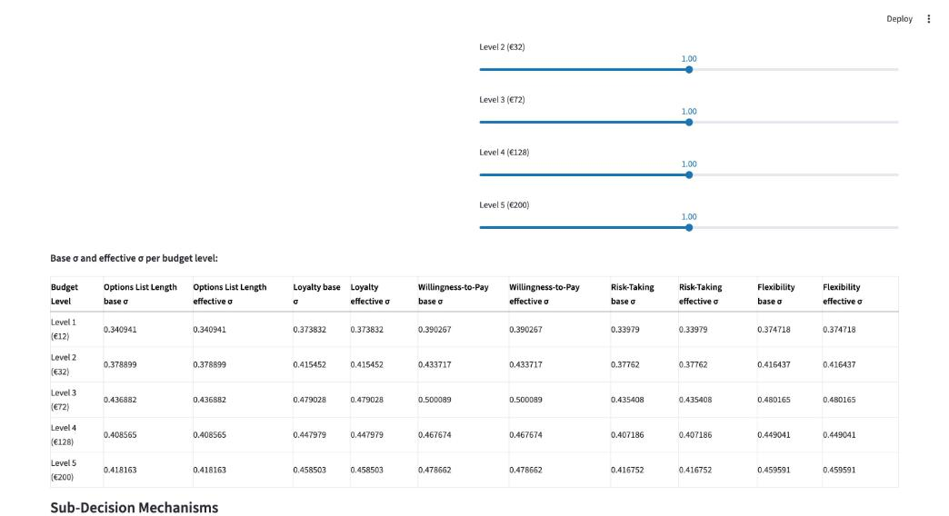
Two arithmetic slips inside the document itself (the app follows the document literally, as instructed): (a) Risk-Taking σ_overall is printed as "0.332208167 × 1.1863376 = 0.39522204", but that product is 0.39411104 – the per-level column IS consistent with the factor; (b) the Loyalty σ_quintile column (0.3738315395 …) equals the previous revision's column multiplied once more by 1.0228235 and does not equal 0.393239139 × mean(stdactions within group) (which would give 0.4022 / 0.4470 / 0.5154 / 0.4820 / 0.4933). TTP, WTP and Flexibility are internally consistent.
The app constants equal the document's tables (every digit); the two inconsistencies above are in the document, not in the app.

Step 11: Integrated default list (document section 6) – app only
The document specifies Kemeny–Young aggregation of the four ranking lists with the tie-breaking hierarchy Schulze → Copeland → footrule → random, truncated to the options list length and at Option 5. It provides no Stata output for it (its stage shares – Kemeny alone 7.7 %, Copeland 43.3 %, footrule 22.7 %, last resort 26.3 % – come from 100 000 random test cases, not from the 280 participants).
App – first integrated default option (whole-decision run) | App – "Run Integrated Default List Only" (export + Use This Config)
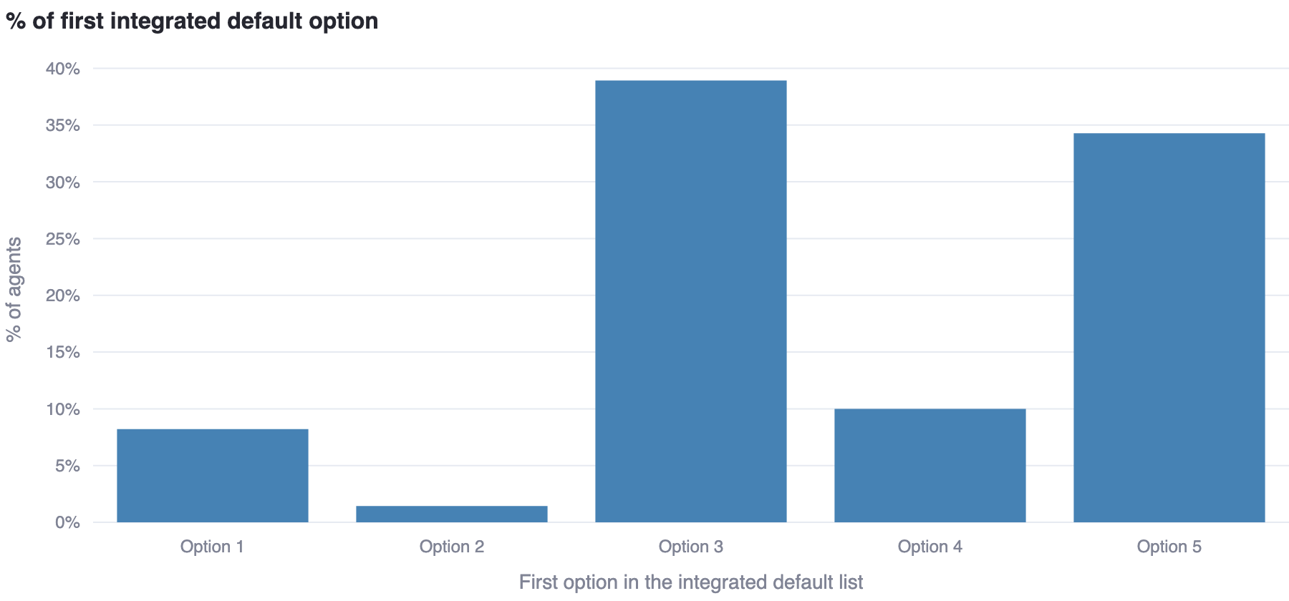 | 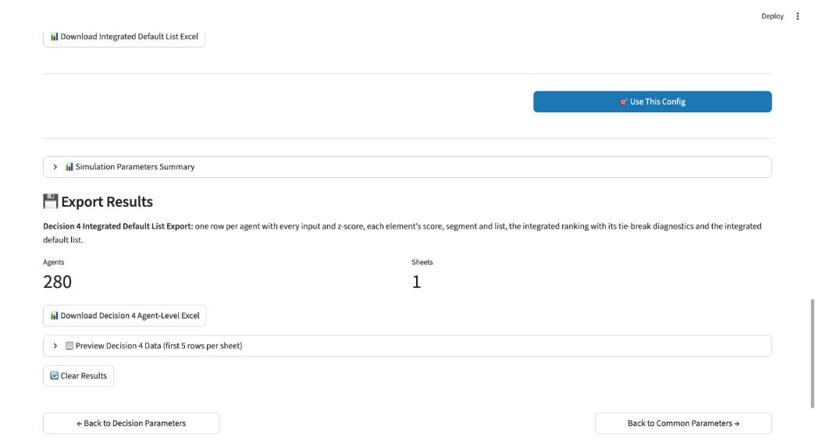

Statistic (Research Baseline, 280, continuous) | App value
Agents with initial ties after Kemeny | 98.9% ({'multiple': 215, 'unique_with_ties': 62, 'unique': 3})
Stage that settled the ranking | footrule: 101 (36.1%), random: 93 (33.2%), copeland: 83 (29.6%), kemeny: 3 (1.1%)
Final ranking Kemeny-optimal | 100.0%
Truncation rule that bound | {'option5': 104, 'length': 100, 'both': 76}
Integrated list length 0/1/2/3 | {'0': 20, '1': 160, '2': 91, '3': 9} (mean 1.32)
First integrated option 1…5 (0 = empty list) | {'0': 20, '1': 23, '2': 4, '3': 109, '4': 28, '5': 96}

App-only step: both output rules hold for 280/280 agents (list length ≤ options list length; nothing after Option 5); the integrated-only run and the whole-decision run produce the same frame.

Step 12: Stochastic component – app example (no Stata figure)
Settings: Page 1 Population = Research Specification (same 280 participants, random order), 280 agents, seed 42; Decision 4 tab: "Use Normal(anchor, σ) draw in Research Specification mode" checked, σ uniform, coefficient 1.00 (σ used: TTP 0.395446, Loyalty 0.4665145, WTP 0.4526575, RT 0.395222, Flexibility 0.4346229); intercepts 0.
The score histograms are those of the deterministic scores (identical to steps 3–9); the draws move the allocations. Options List Length allocation, deterministic vs stochastic:
Options | Deterministic count | % | Stochastic count | % (UI shows 2.1 / 22.1 / 29.6 / 32.9 / 11.1 / 2.1)
0 | 20 | 7.1% | 6 | 2.1%
1 | 92 | 32.9% | 62 | 22.1%
2 | 95 | 33.9% | 83 | 29.6%
3 | 57 | 20.4% | 92 | 32.9%
4 | 14 | 5.0% | 31 | 11.1%
5 | 2 | 0.7% | 6 | 2.1%

App – TTP score (Research Specification, σ on) | App – allocation with the Normal(anchor, σ) draw
 | 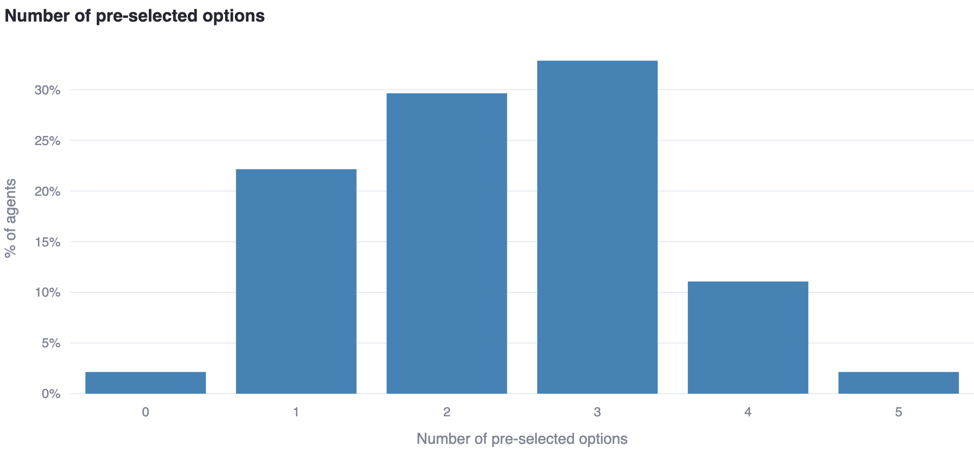

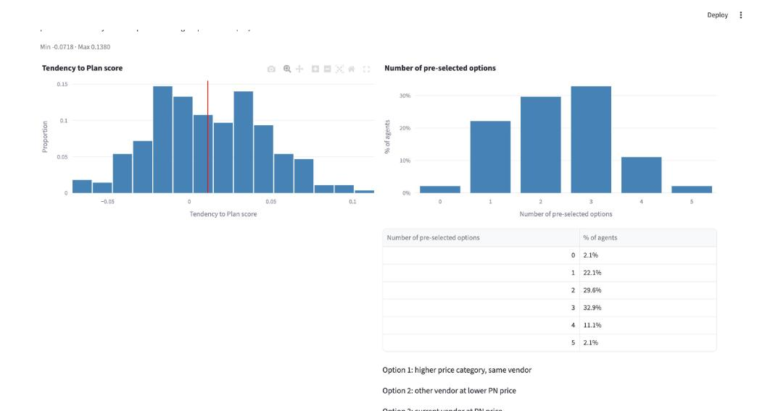
App-only step: the on-screen stochastic allocation equals the engine's for the same seed (UI = engine), and the draws are reproducible by seed.

Step 13: Comparison layouts and Copula
"Compare both" (Decision 4 tab) renders the income-independent elements once and WTP / Risk-Taking / integrated list per income treatment; "Compare all" (Page 1) renders one column per population mode. Each column equals the corresponding single-mode run (verified per agent through the seam).
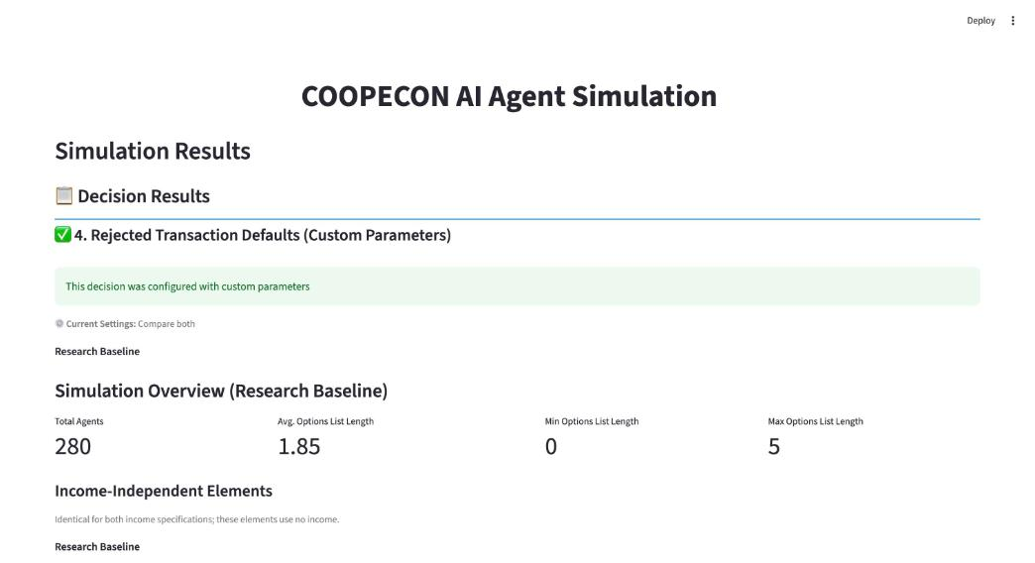
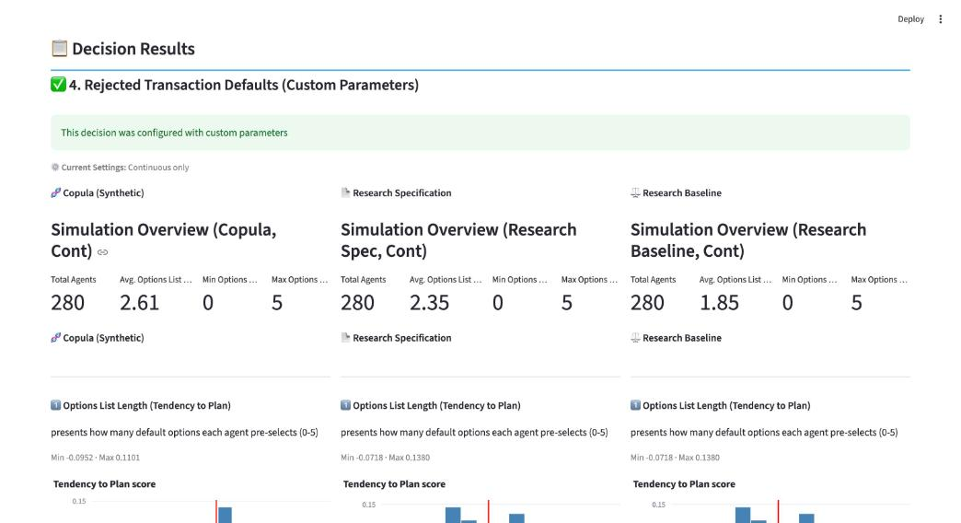
As in the Decision 1 comparison, the Copula column cannot match the Stata values: it is a synthetic population bootstrapped from the fitted copula, never the original 280 participants (here Min −0.0952 / Max 0.1101 for the TTP score vs −0.0718 / 0.1380). Research Specification and Research Baseline carry the original participants; with σ off they give the same multiset of per-agent values (Research Specification permutes the order).
Consistent: the comparison grids reproduce the single-mode values; Copula differs by construction.

Appendix A: Per-participant verification against the .dta (controller script, seam path)
Research Baseline, 280 agents, seed 42, intercepts 0, W_OFlex 0.25, σ off; rows joined on Participant ID.
Stata column | App column | Participants matching | max |diff|
weighted_ttp | rtd_weighted_ttp | 280/280 | 1.8e‑08
choice_length_deterministic | rtd_choice_length | 280/280 | 0
weighted_loyalty | rtd_loyalty_z | 280/280 | 3.2e‑07
weighted_loyalty15 | rtd_loyalty_segment | 280/280 | 0
choice1…5_loyalty_deterministic | rtd_loyalty_ranking | 280/280 | 0
z_WTP_calculated (continuous) | rtd_wtp_z | 280/280 | 8.1e‑06
WTP_calculated15 | rtd_wtp_segment | 280/280 | 0
choice1…5_WTP_deterministic | rtd_wtp_ranking | 280/280 | 0
z_WTP_categorical (stored .dta column) | rtd_wtp_z (categorical) | 0/280 – superseded formula in the .dta (step 6); app = document code to 9e‑09 | 6.2e‑02
floor rule on z_WTP_categorical (.dta) | rtd_wtp_segment (categorical) | 279/280 | –
z_RT_calculated_hs (continuous) | rtd_rt_z | 280/280 | 1.7e‑07
RT_calculated15 | rtd_rt_segment | 280/280 | 0
choice1…5_RT_deterministic | rtd_rt_ranking | 280/280 | 0
z_RT_categorical | rtd_rt_z (categorical) | 280/280 | 2.0e‑07
floor rule on z_RT_categorical | rtd_rt_segment (categorical) | 280/280 | –
z_Flexibility_calculated_ivw | rtd_flex_z_ivw | 280/280 | 1.8e‑07
z_stdactionsP | rtd_z_stdactions | 280/280 | 1.6e‑07
z_anchored_flexibility | rtd_flex_z | 280/280 | 2.2e‑07
Flexibility_combined15 | rtd_flex_segment | 280/280 | 0
choice1…5_flex_deterministic | rtd_flex_ranking | 280/280 | 0

Appendix B: Document / data errors found
- The stored column weighted_WTP_categorical in Stata_File_Decision4_050926.dta (and therefore z_WTP_categorical and figure F7) was produced with a superseded formula (see step 6); the document's printed cond() code is what the app implements.
- Risk-Taking σ_overall: the document prints 0.332208167 × 1.1863376 = 0.39522204; the product is 0.39411104.
- Loyalty σ_quintile column: the document's five per-allowance values are the previous revision's column multiplied by 1.0228235 again and do not follow from the stated factor 0.393239139.
- Flexibility: the document lists "histogram z_Flexibility_calculated_hs" and Risk-Taking "histogram z_RT_calculated_ivw" without the corresponding figures (the IVW/H&S alternatives that were not retained).
- The document still contains tracked changes (deleted previous-revision figures and choice mappings); this comparison uses the accepted-changes text and figures.

